Web Applications and Databases coursework part 1 (CST2120)

Daniel Karimi

Student Number

M01008906

# Agenda

* Brief explanation
* Home page
* Game page
* Ranking table page

# Brief explanation

I embark with brief explanation of the website then I elaborate each single webpage in detailed as a compelling narrative along the impediments caught me during creation, pertinent to the webpage under discussion. The pages are index.html which is the home page, game.html and users.html. Upon the user’s visit to the website, they can navigate to the following pages:

* Login / Register page accessible to only logged out user, being named index.html.
* Ranking score table accessible to every user overlooking the logged in status of them.
* The chicken crossing page accessible to only logged in user, it displays logged in user’s name, email, score (or level), coins obtained by far correspond with logged in user, computer score if the player has chosen to play against the computer, logout button, a message box to fill them with a substantial information, and the game itself.

I should add this point that navbar is shared in all pages.

# Home Page

On top of the page just below the navbar there is a significant message to let the visitor know they can access to the game only in case of being logged in.

## Register form, input validation and error handling

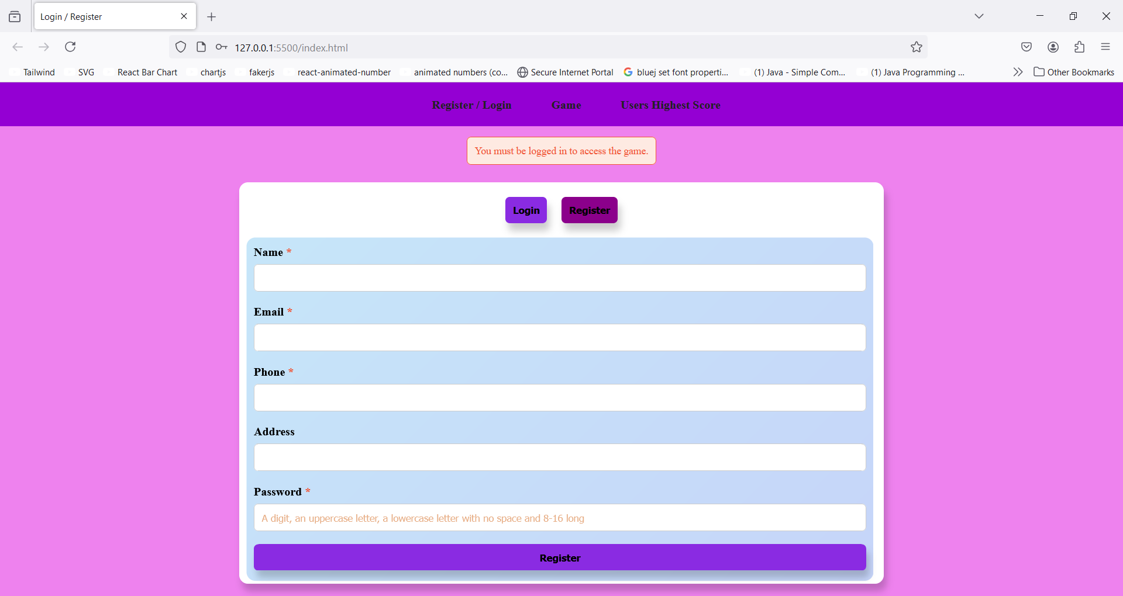

### Input validation and error handling

For illustrating the point where the user has already existed, I start with registration of an existing user. List of existing users is presented with a screenshot of localStorage users list:

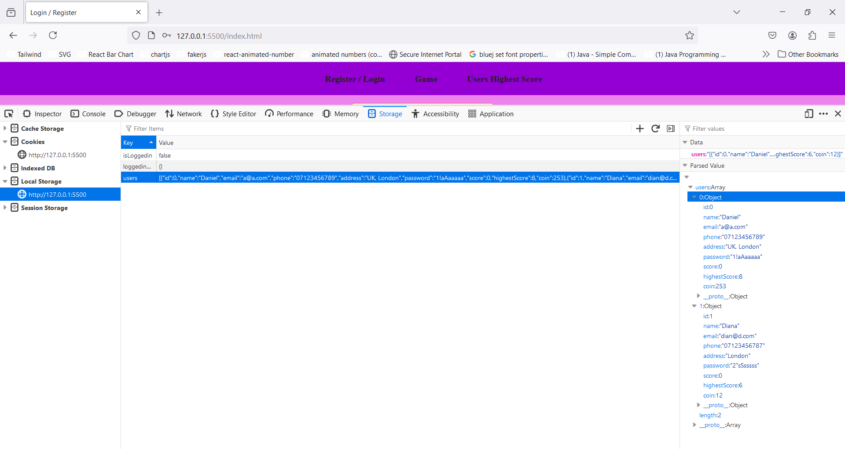



Then I register a new user and depict the localStorage and game page to demonstrate the user has been added to the users list successfully and their score, highest score and collected coins by them starts at value 0. Let’s start with trying to register an existing user.

If the visitor mistakenly submits the form without filling the inputs fields a box for the first input with an invalid value appears to inform them of the amiss, they made:

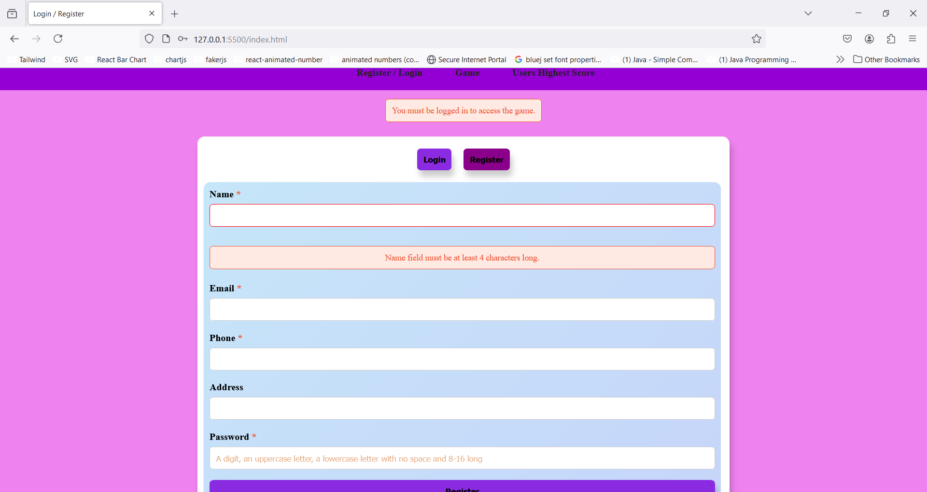

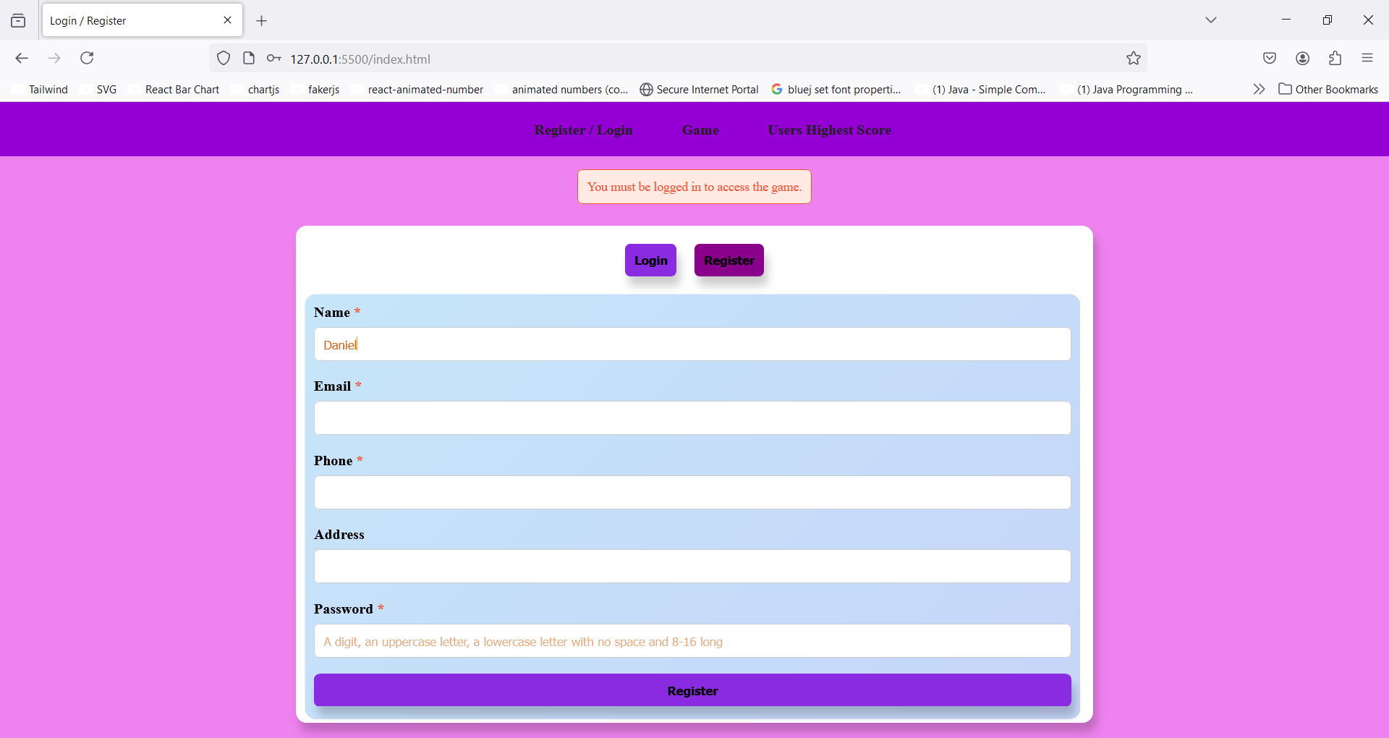

The valid value for email input field is when the user enters a string followed by @ sign then another string followed by dot (“.” sign) then a string again:

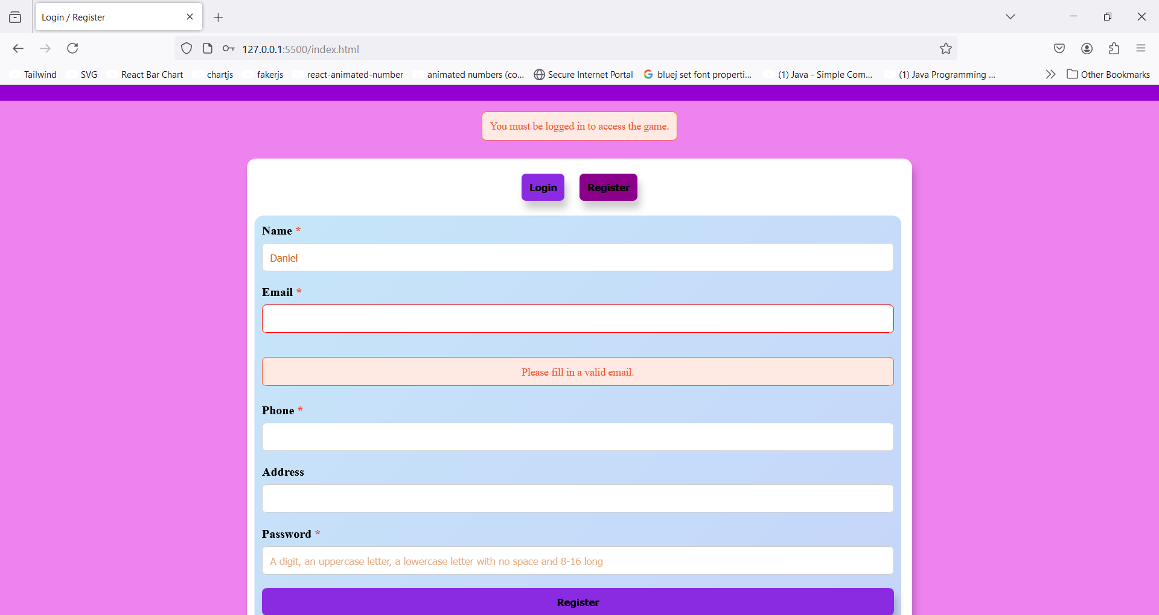

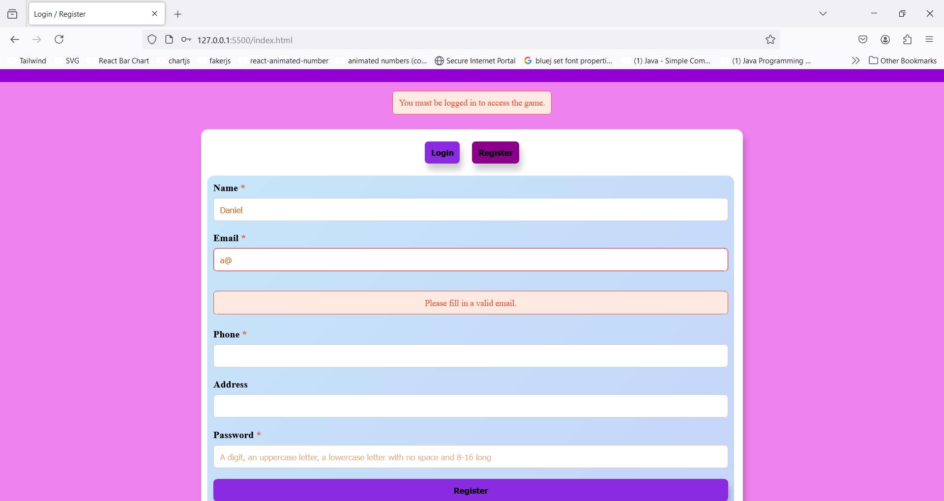

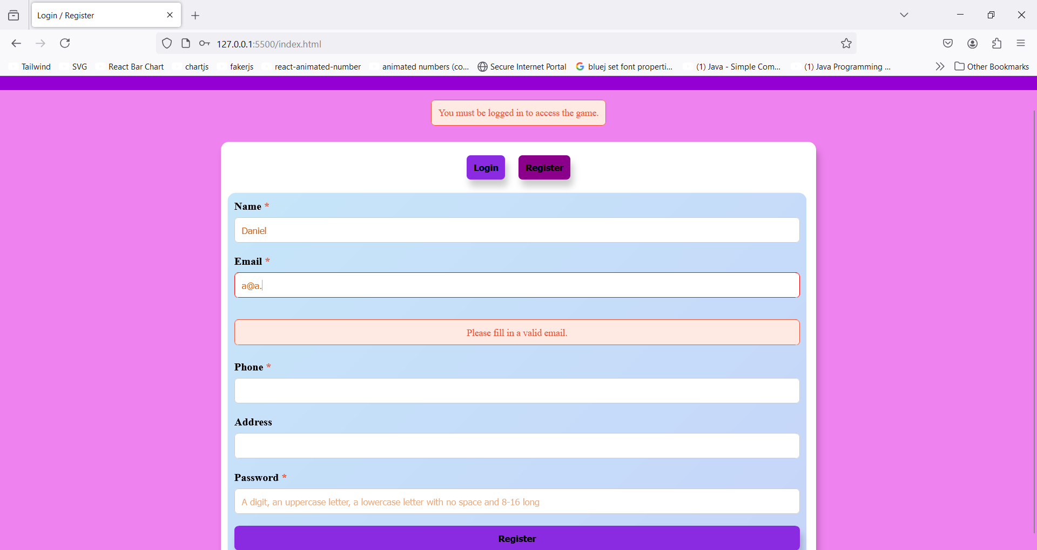

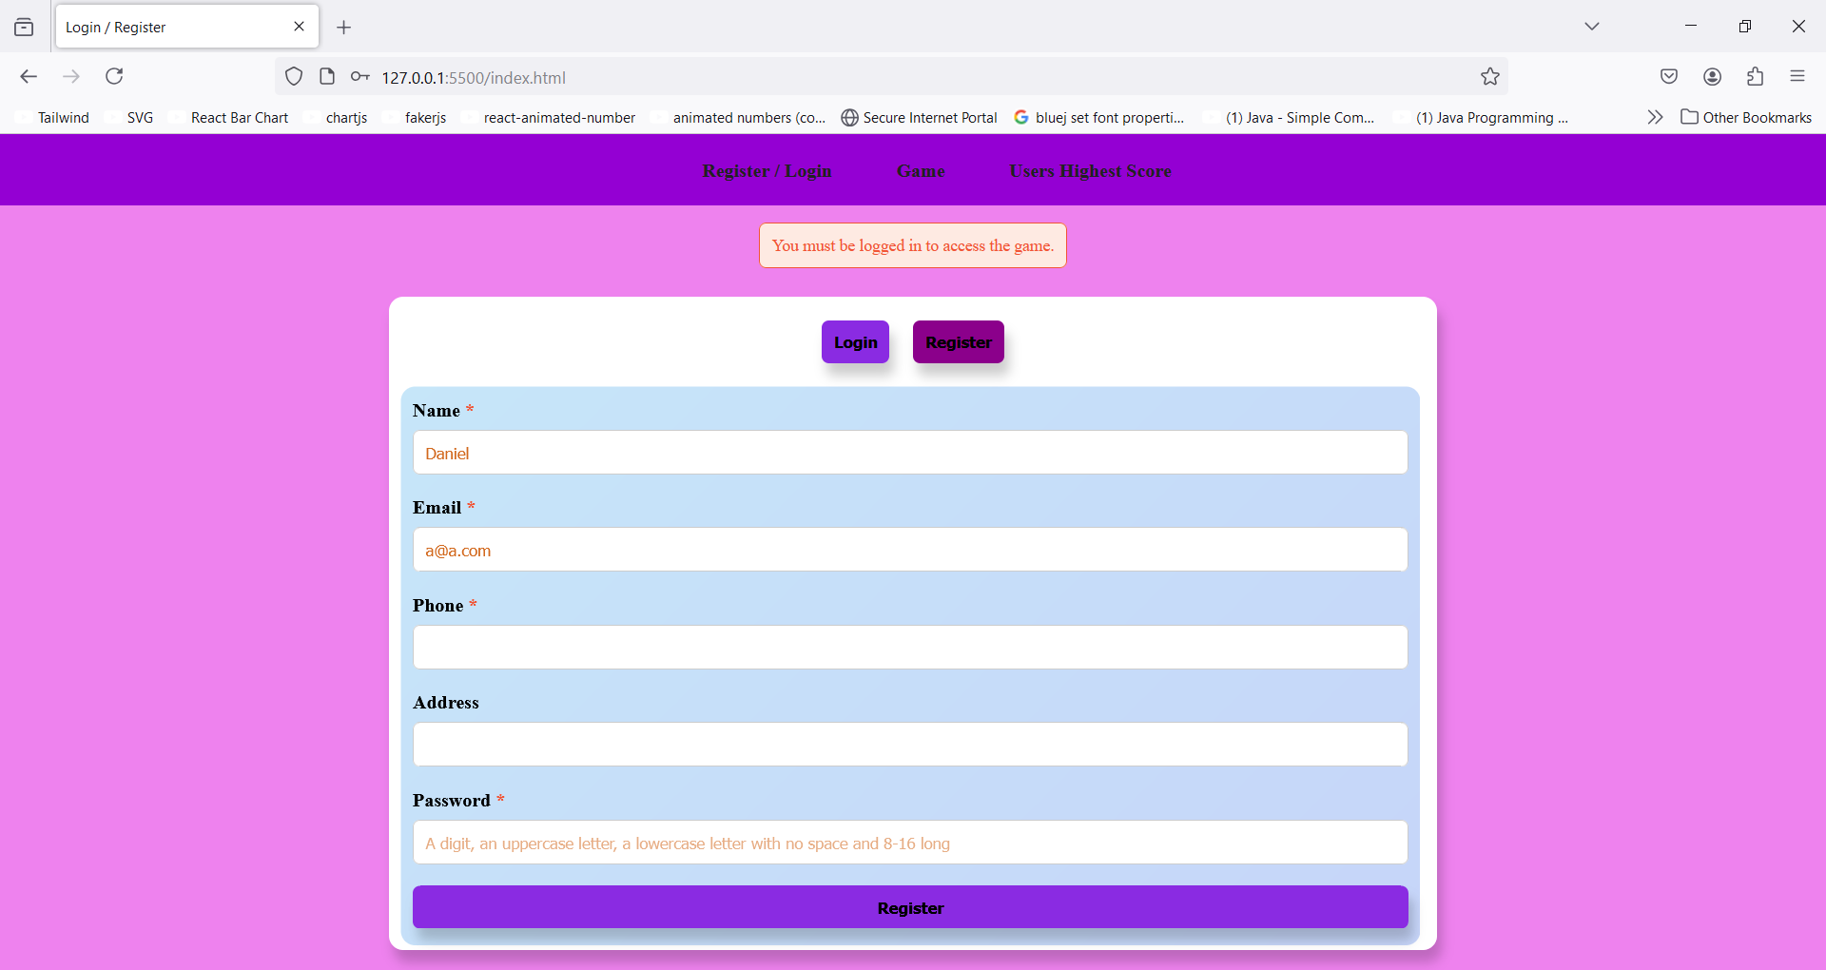

Phone input value would be valid if it starts with a leading 0 followed by 10 digits:

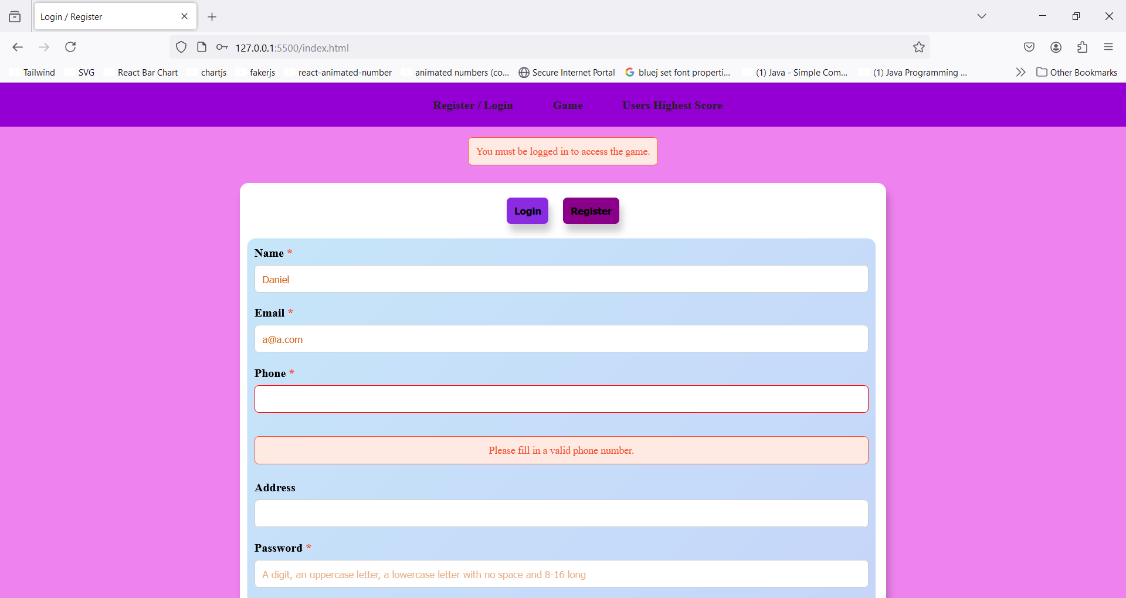

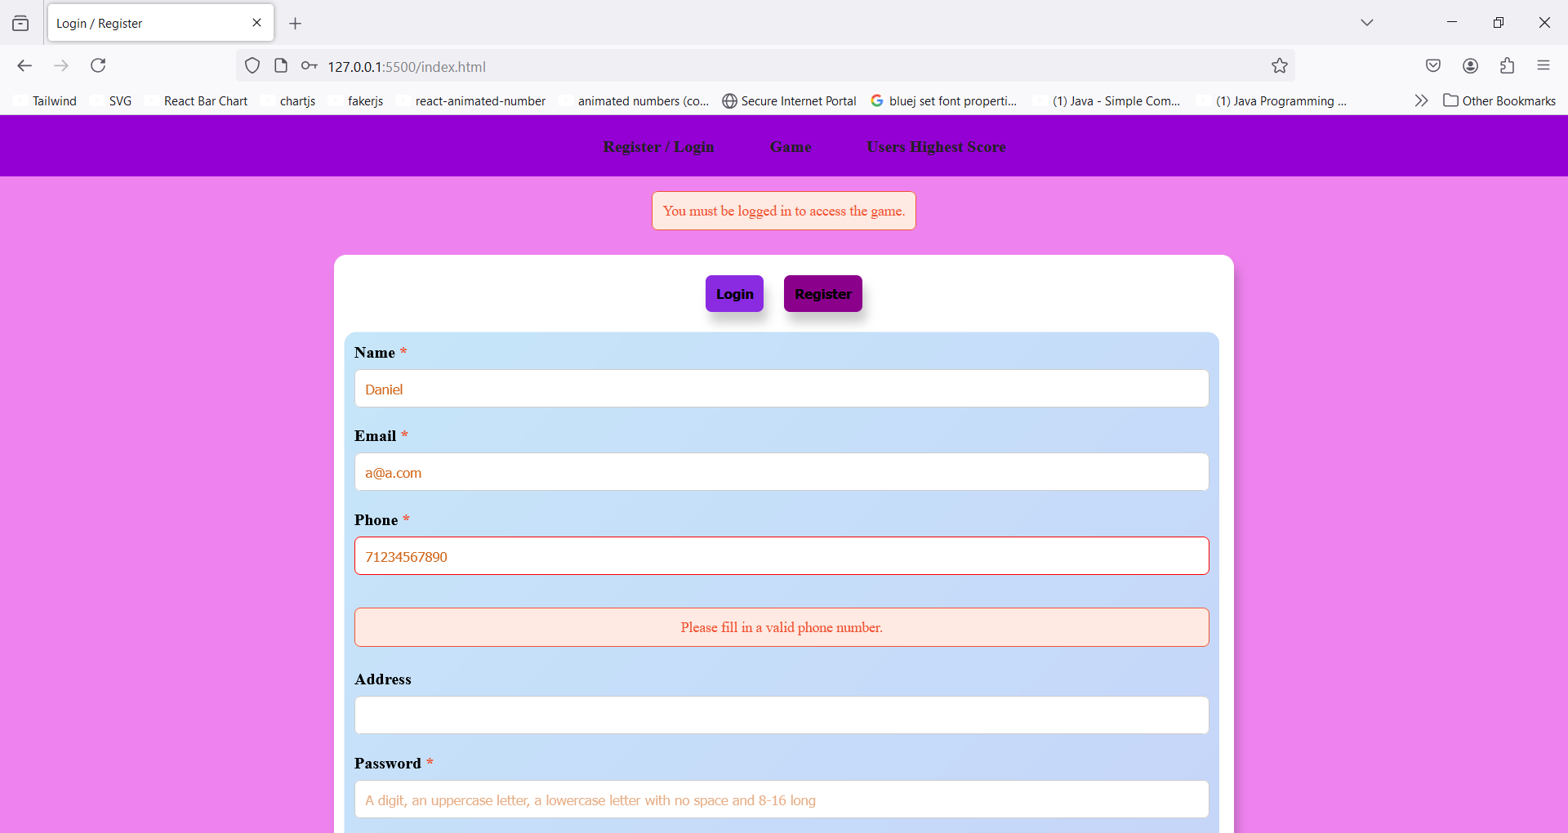

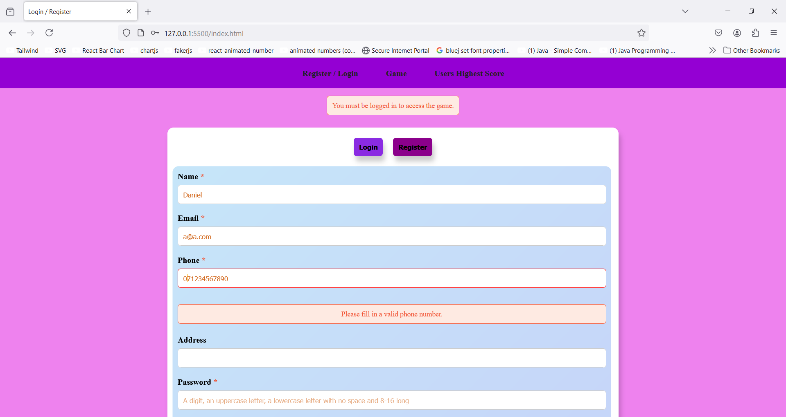

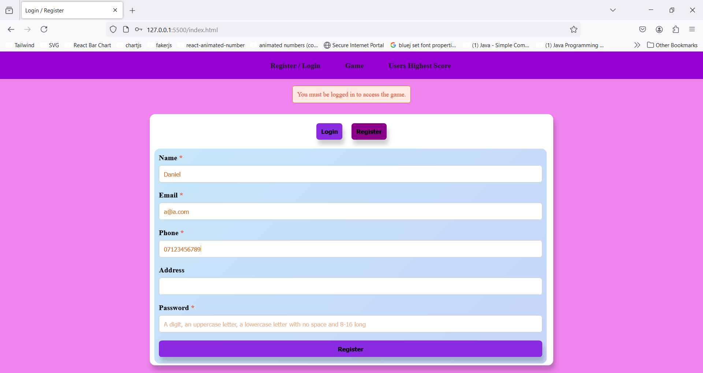

Address field has no validation assigned to and its relevant input has not got required attribute.

Lastly for password field, the value must pass this validation: it must contain at least a digit, at least an uppercase letter, at least one lowercase letter, between 8-16 characters long with no space:

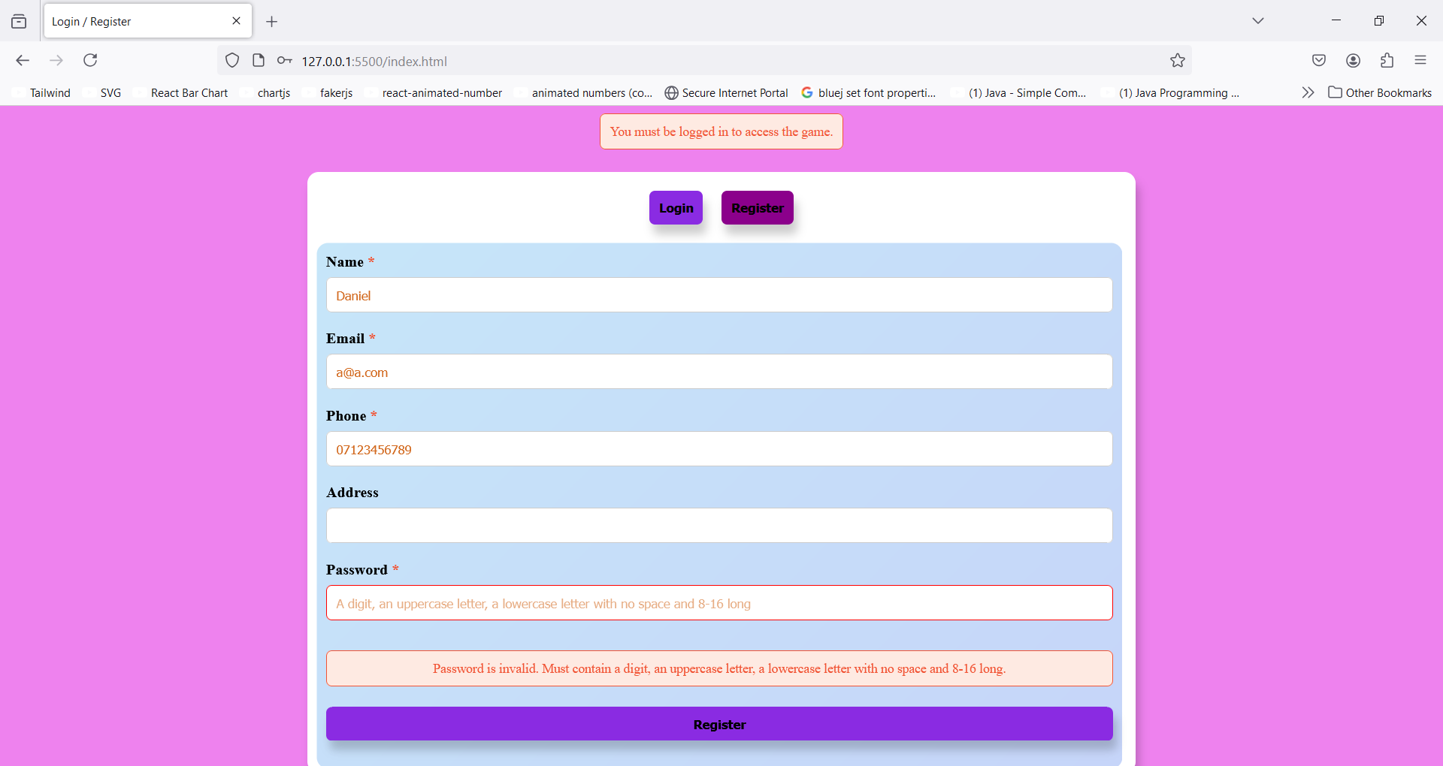

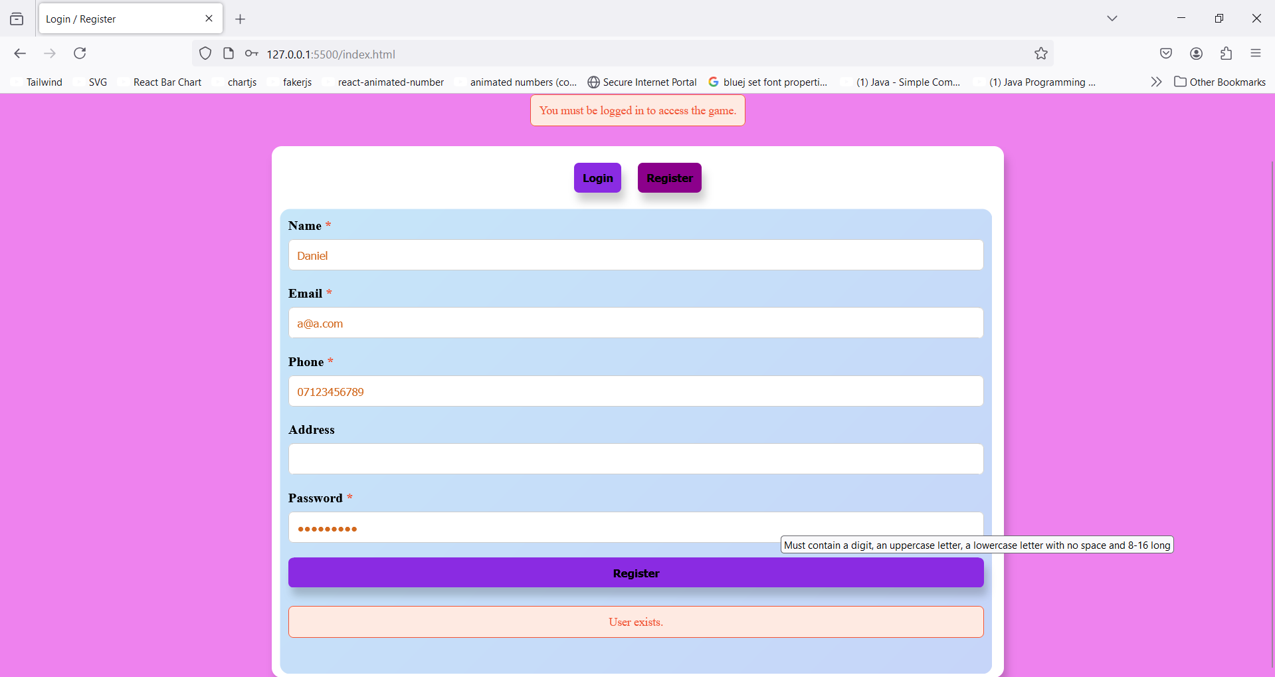

I now register a new user and insert the above-mentioned indications:

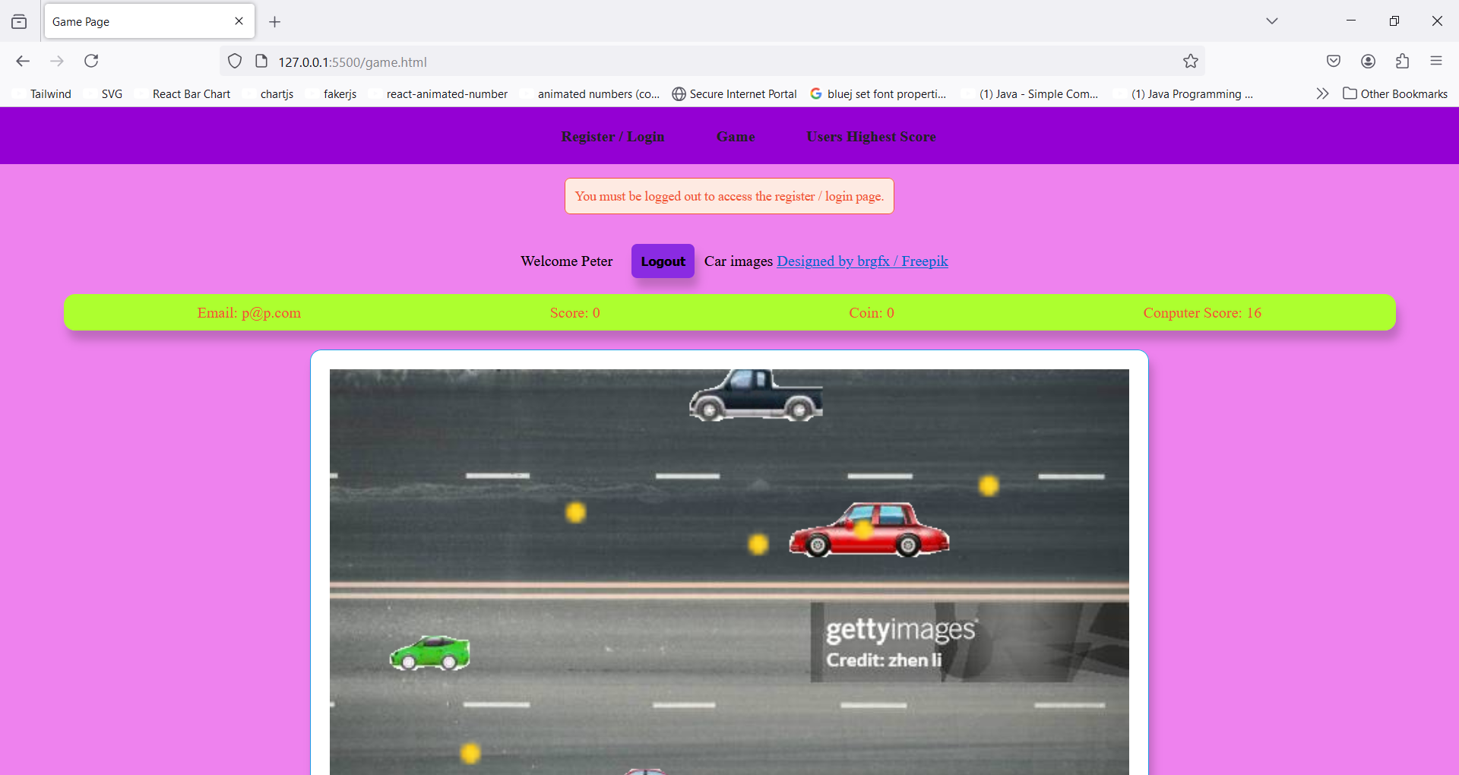

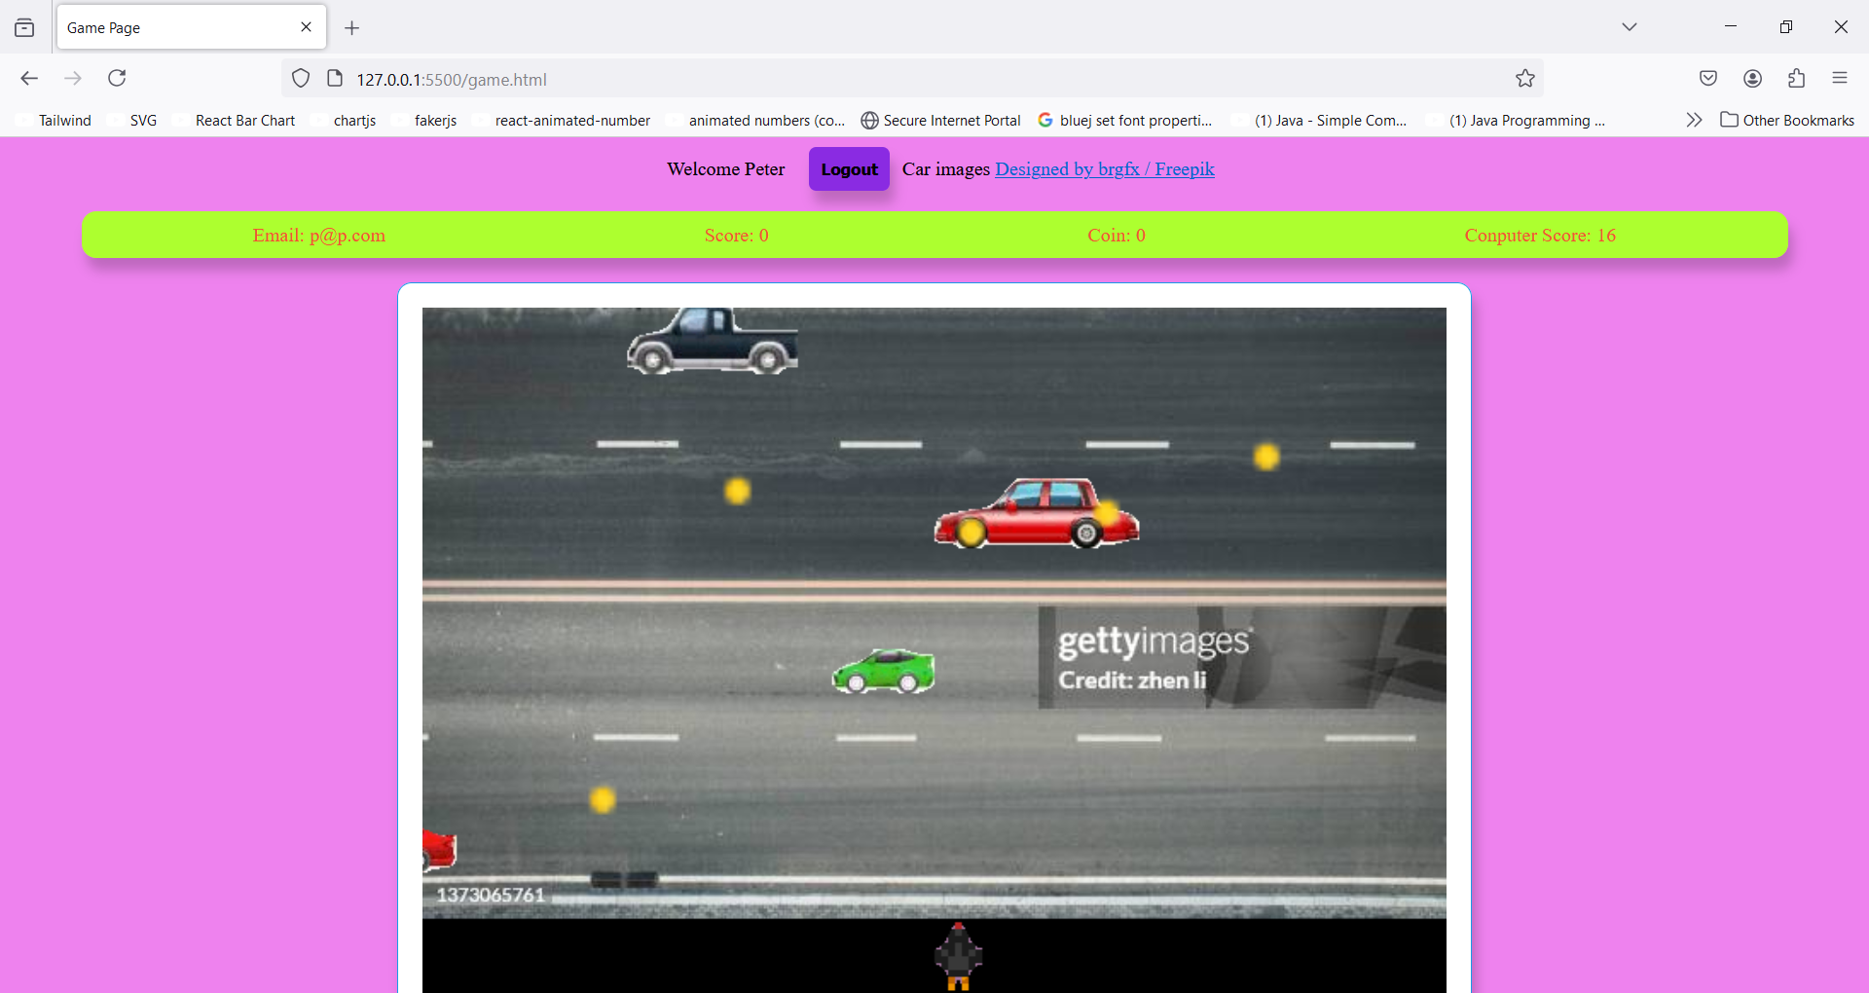

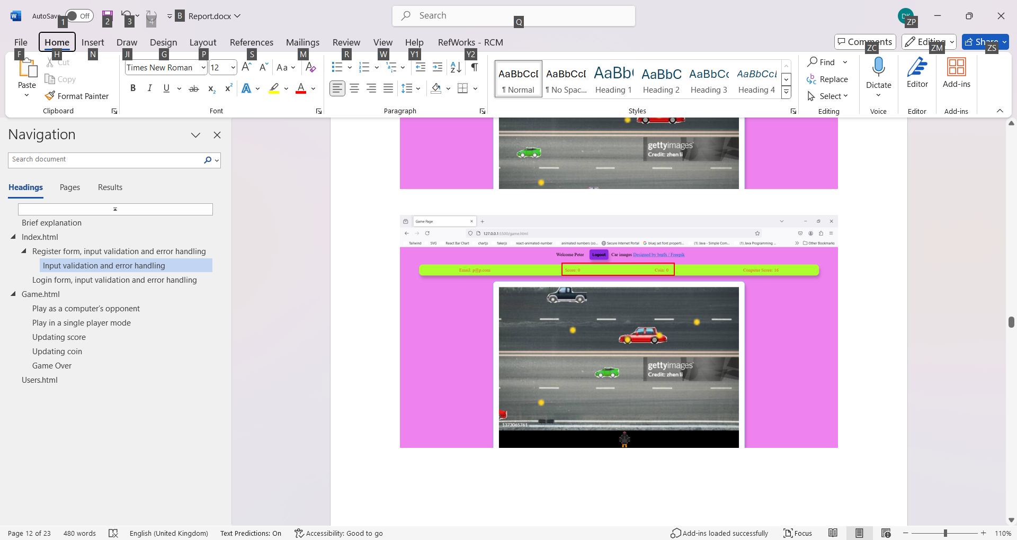

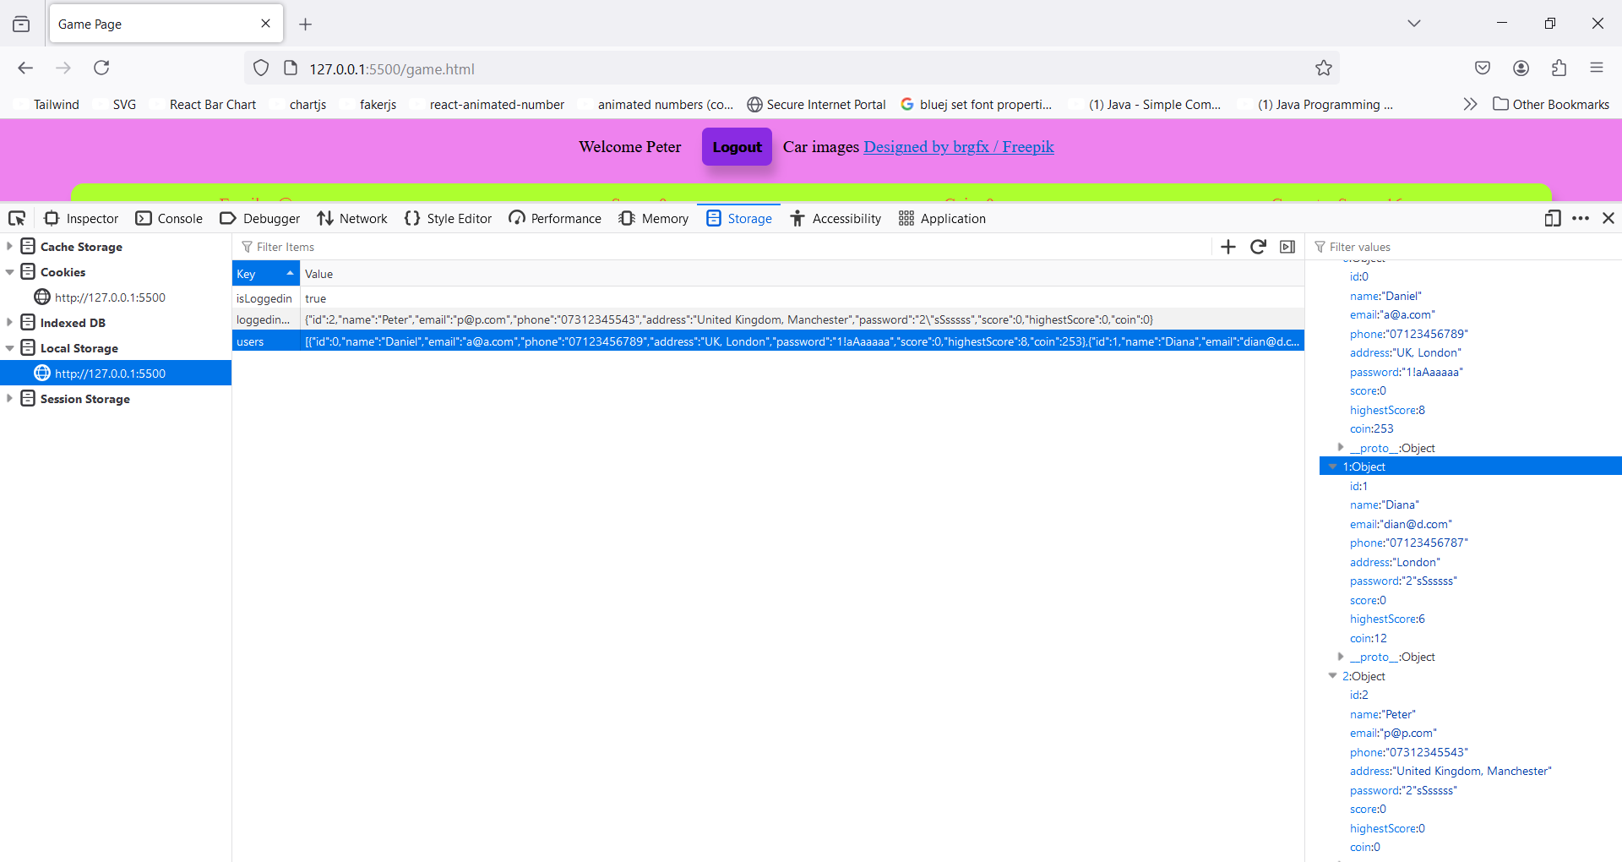



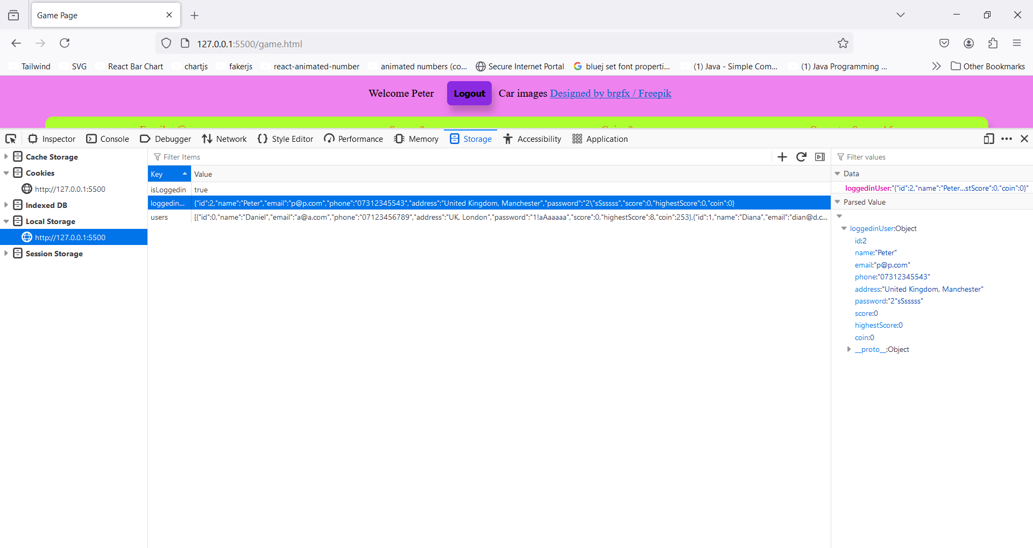



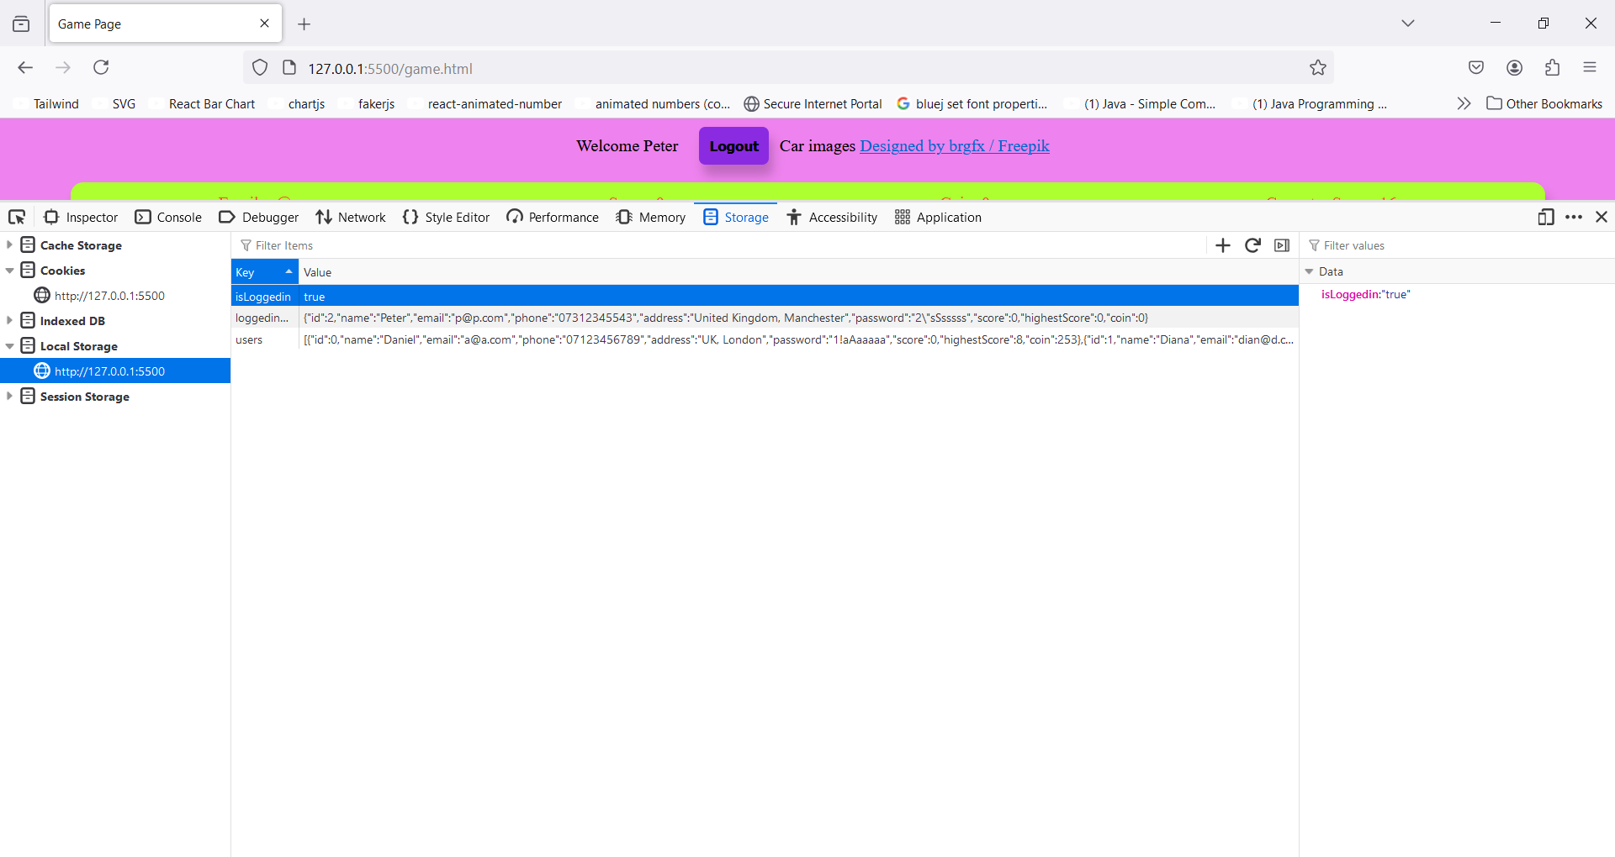



## Login form, input validation and error handling

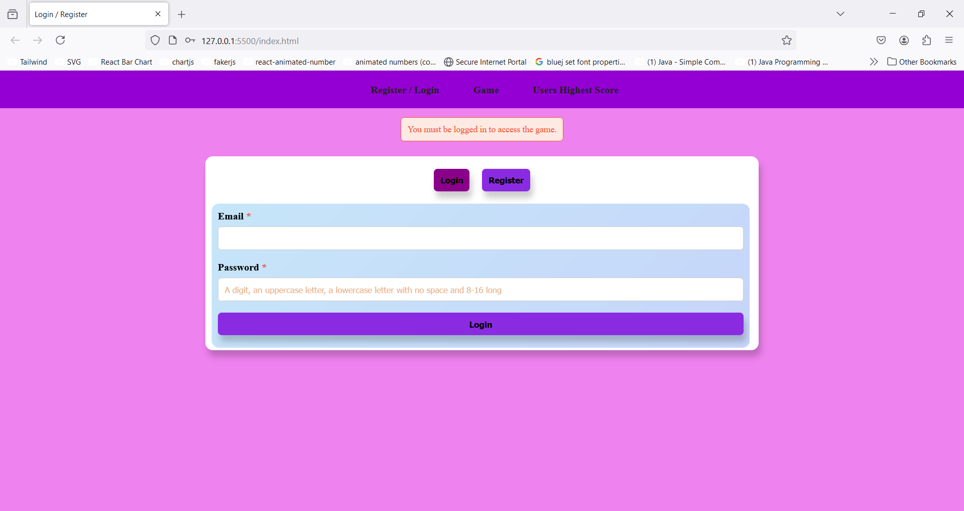

### Input validation and error handling

In terms of login form if the values inserted are invalid, form validation works almost the same as register form, however, if the values are valid various and dissimilar error message might appear contingent upon the email, password or both values:

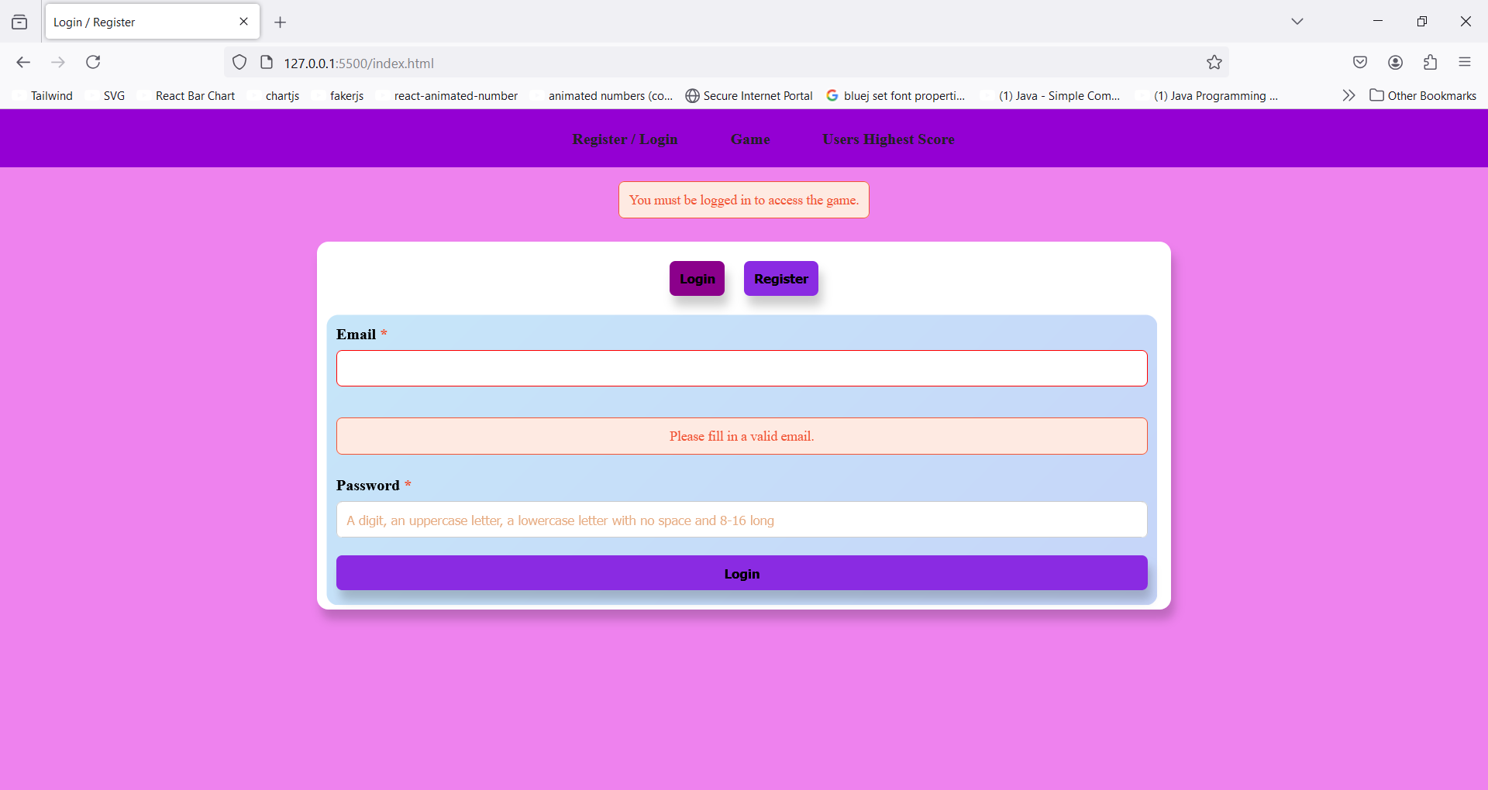

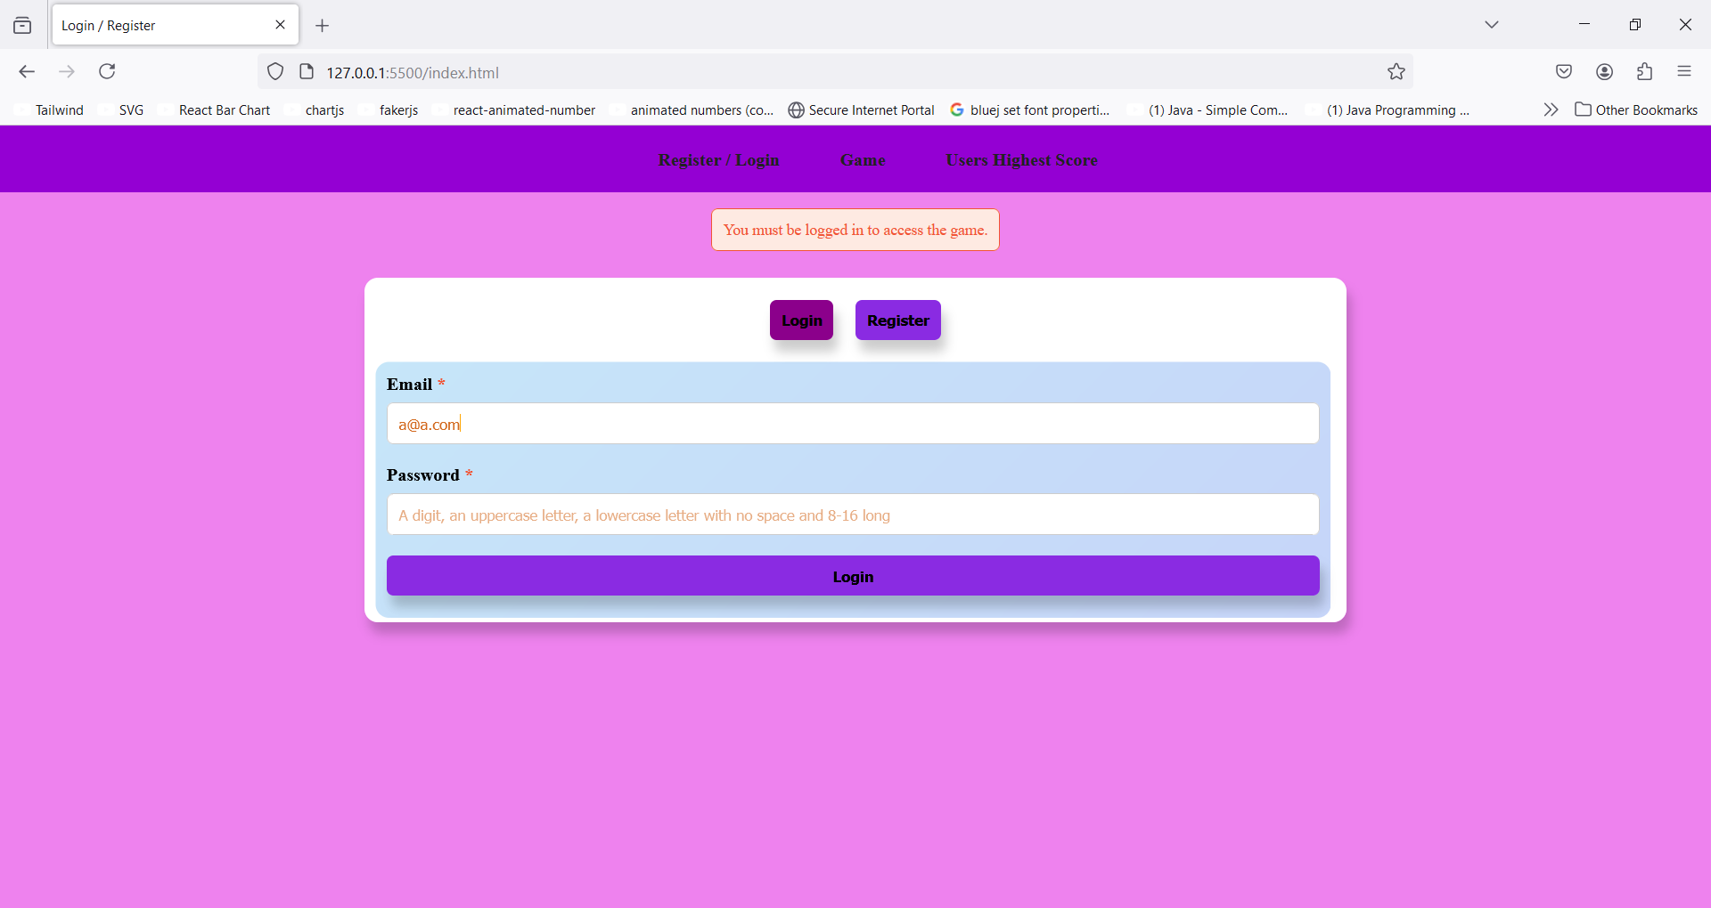

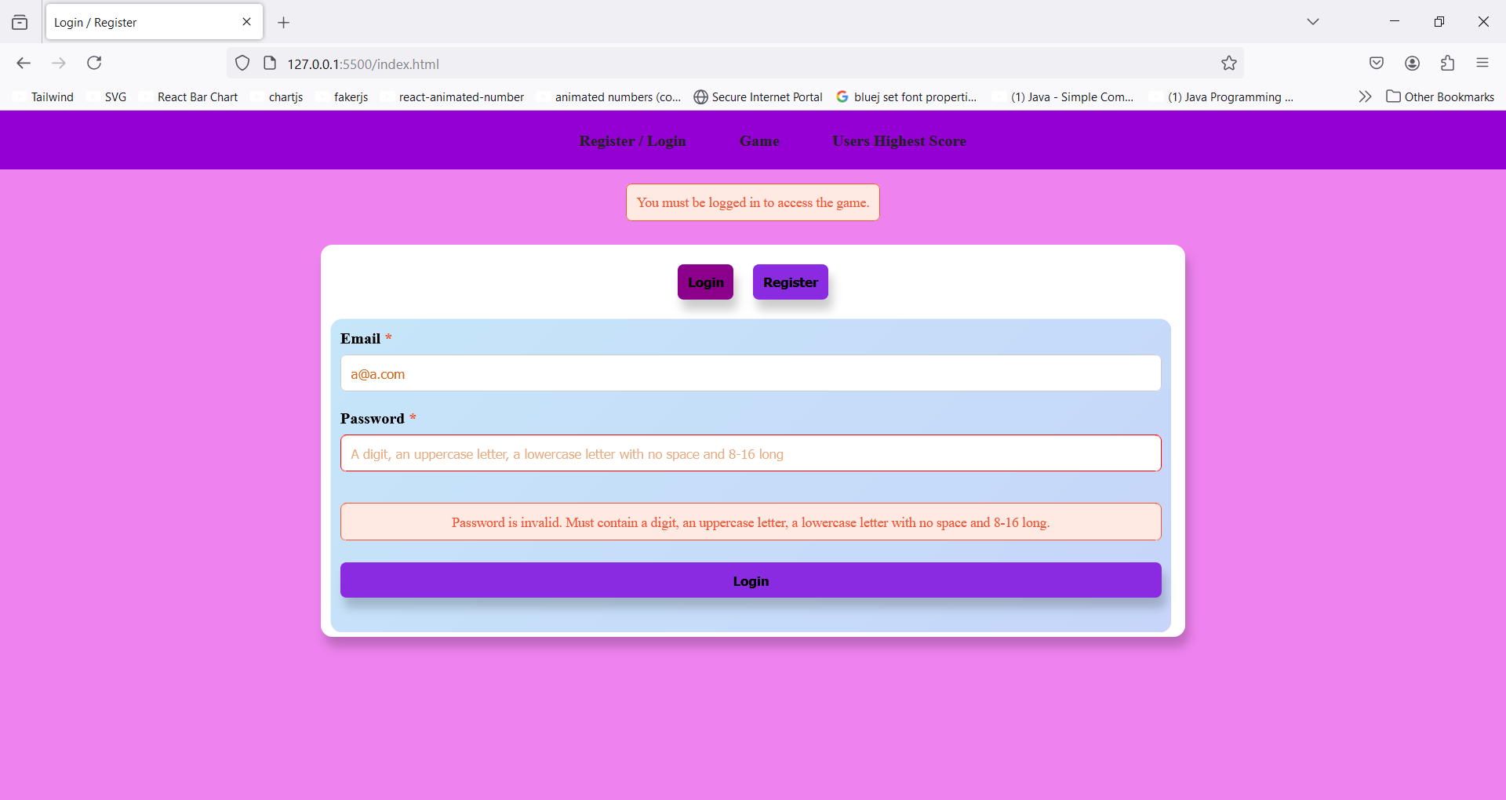

In case that email exists in users list, but the entered password does not match the password for that user stored in users list an error appears states “Password incorrect.”:

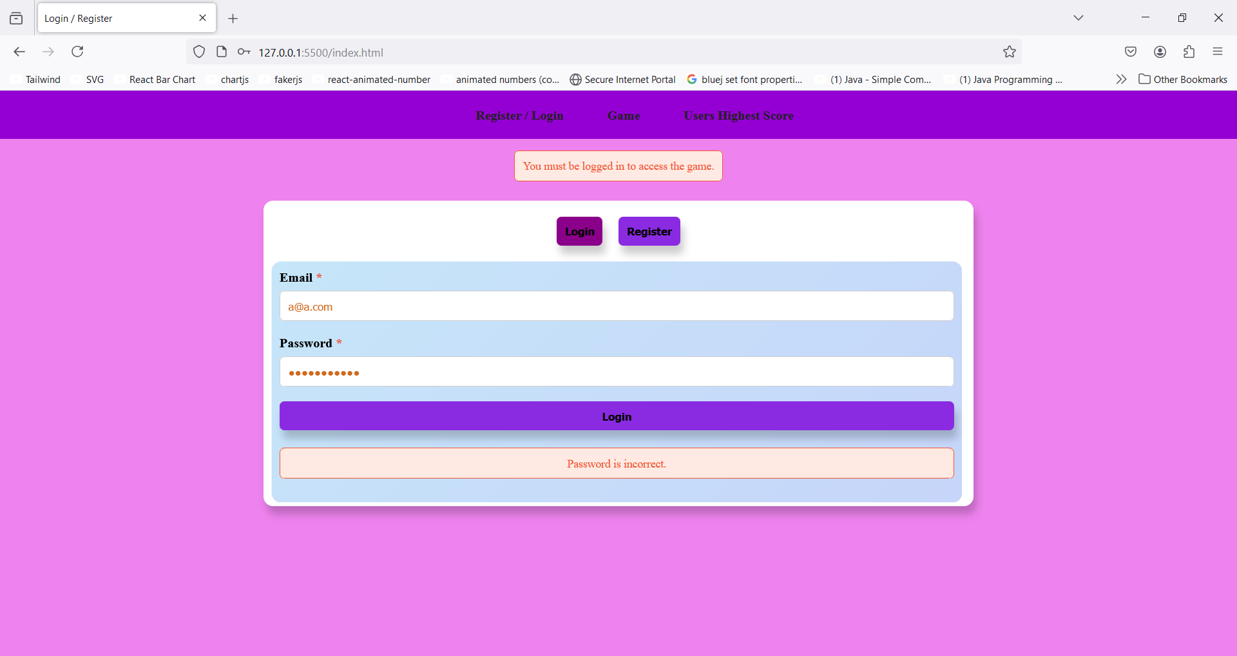

However, if the entered password exists in users list but the entered email does not match the one held for the user that is stored in users list the same error box with different error message appears and says, “Email does not match the ones we have on our system.”:

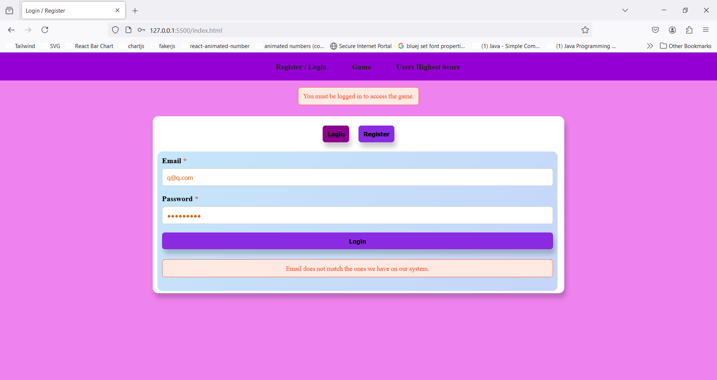

Finally, if none of the entered password and entered email exist in users list error message appears and cites, “Email and password does not exist.”:

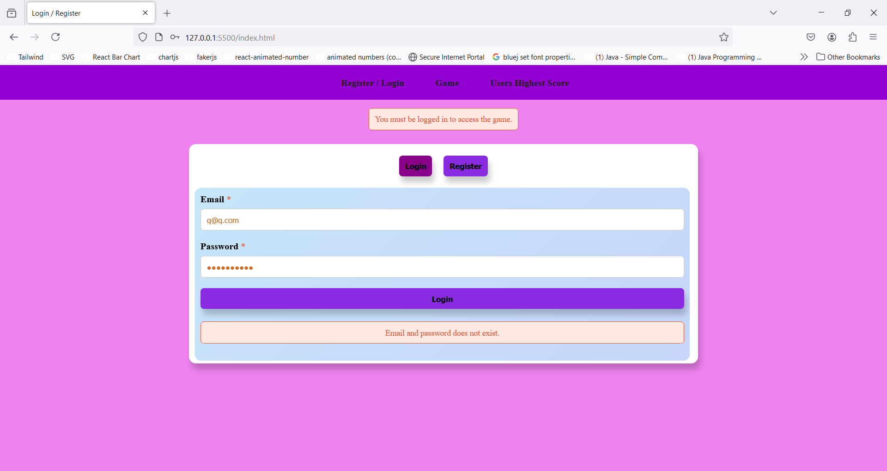

Or the inserted values match a user in users list, in that peculiar situation user logs in and can access the game, I include screenshot of already existence users in localStorage and a screenshot of game page after they log in:

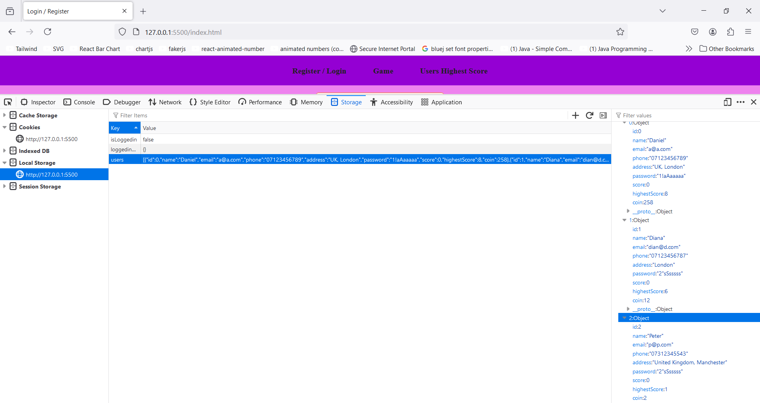



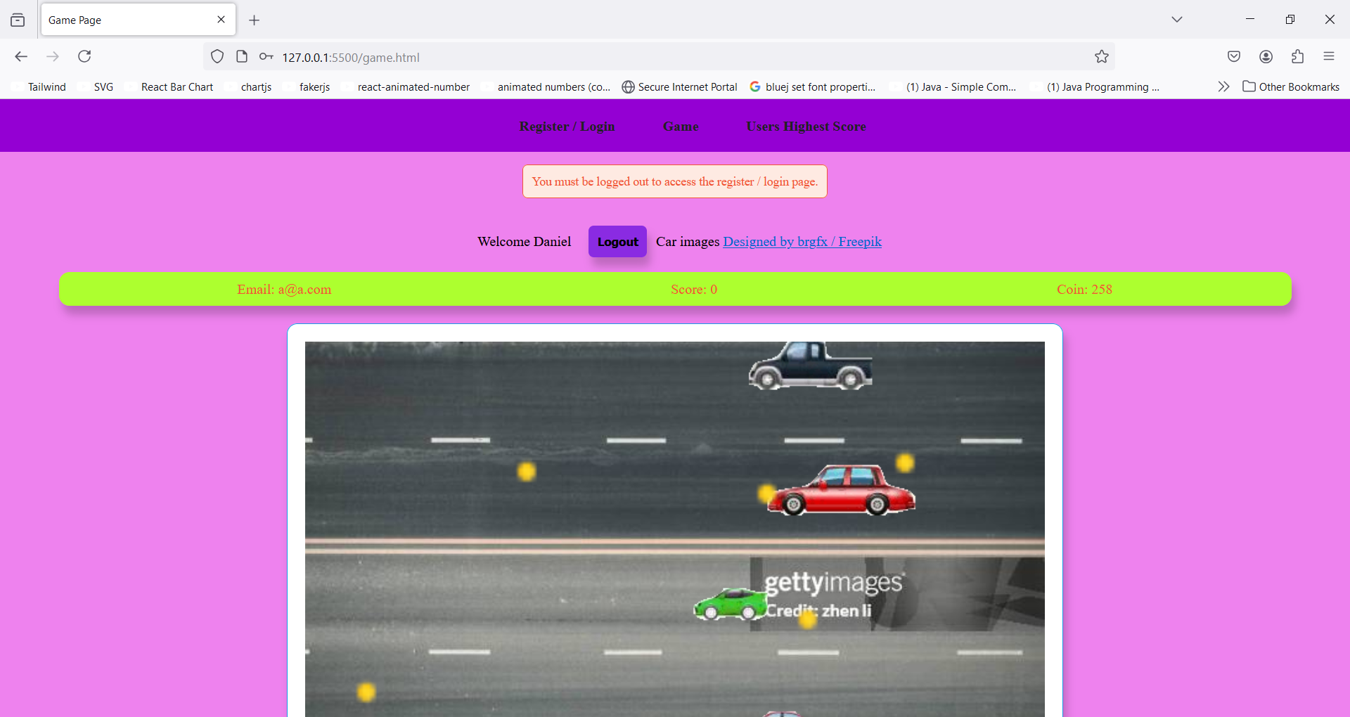

# Game page

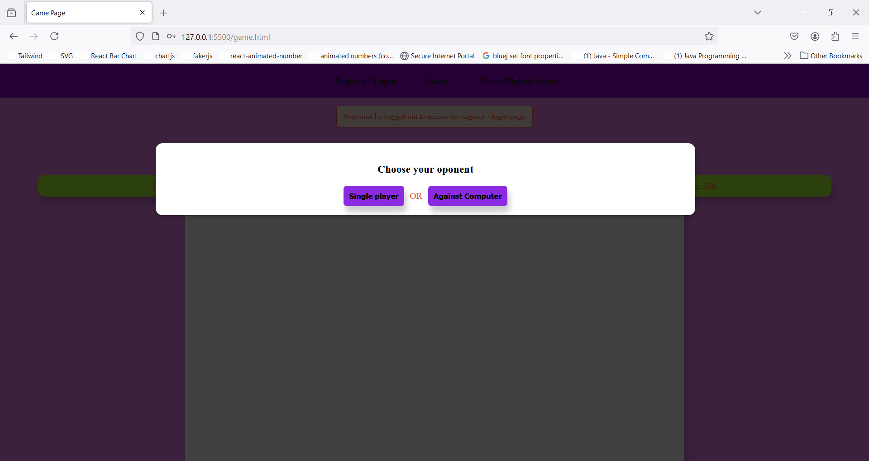

## Play as a computer’s opponent

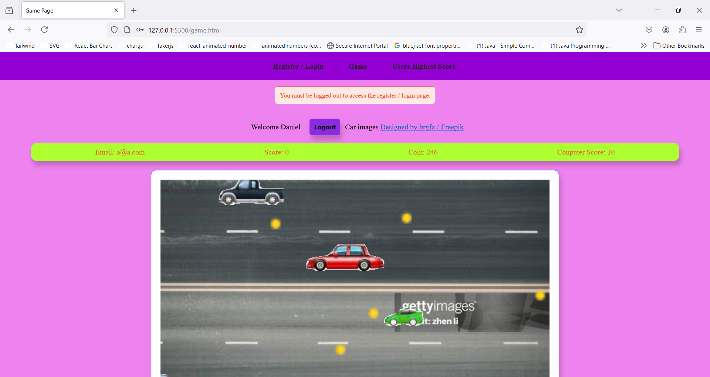

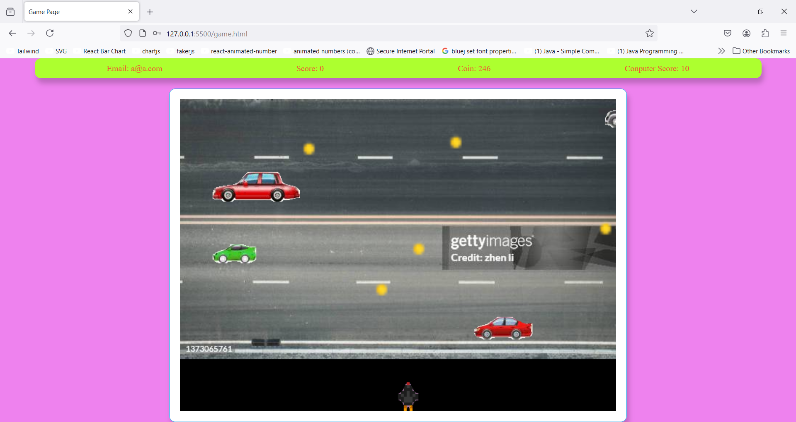

## Play in a single player mode

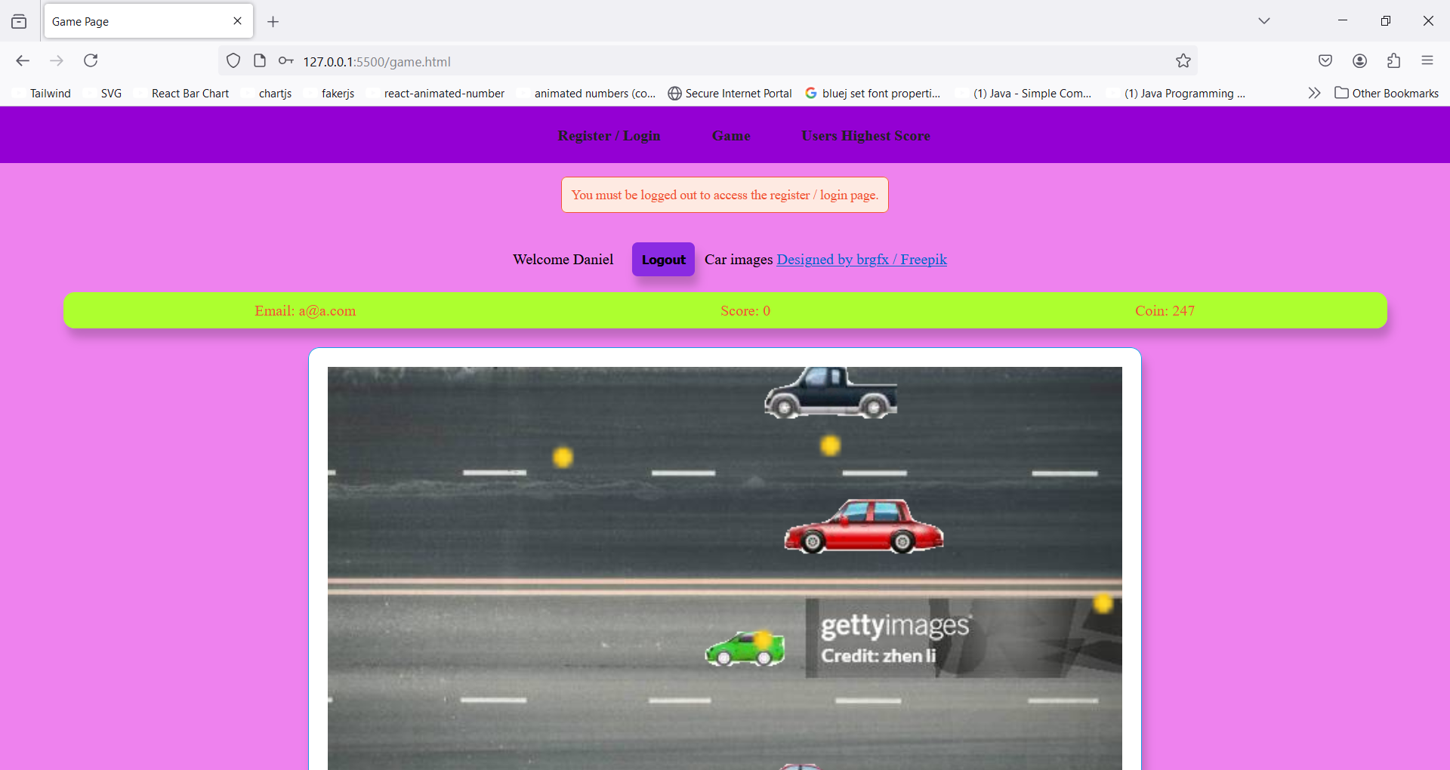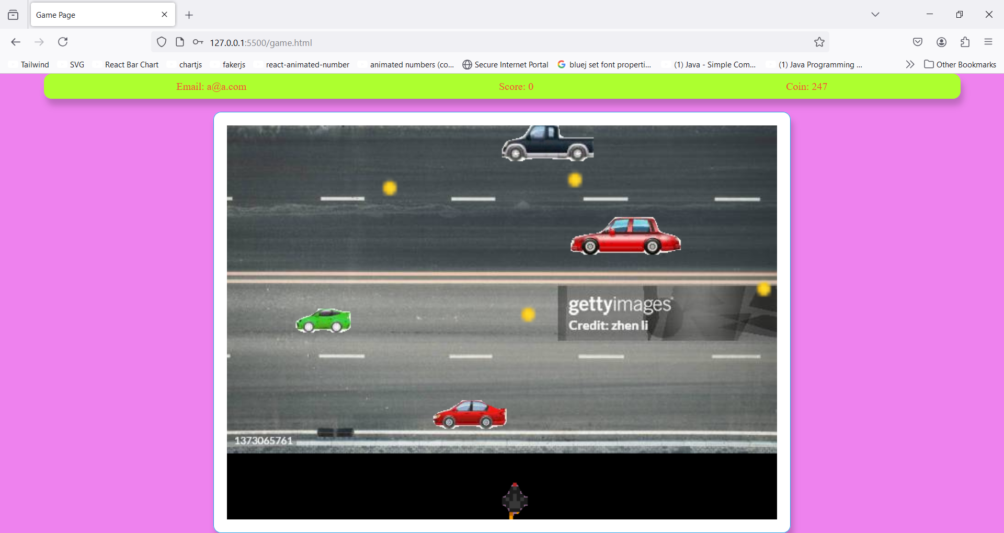

## Updating score

Every time the player crosses the street their score and cars speed respectively incremented by one and three pixels in movement:

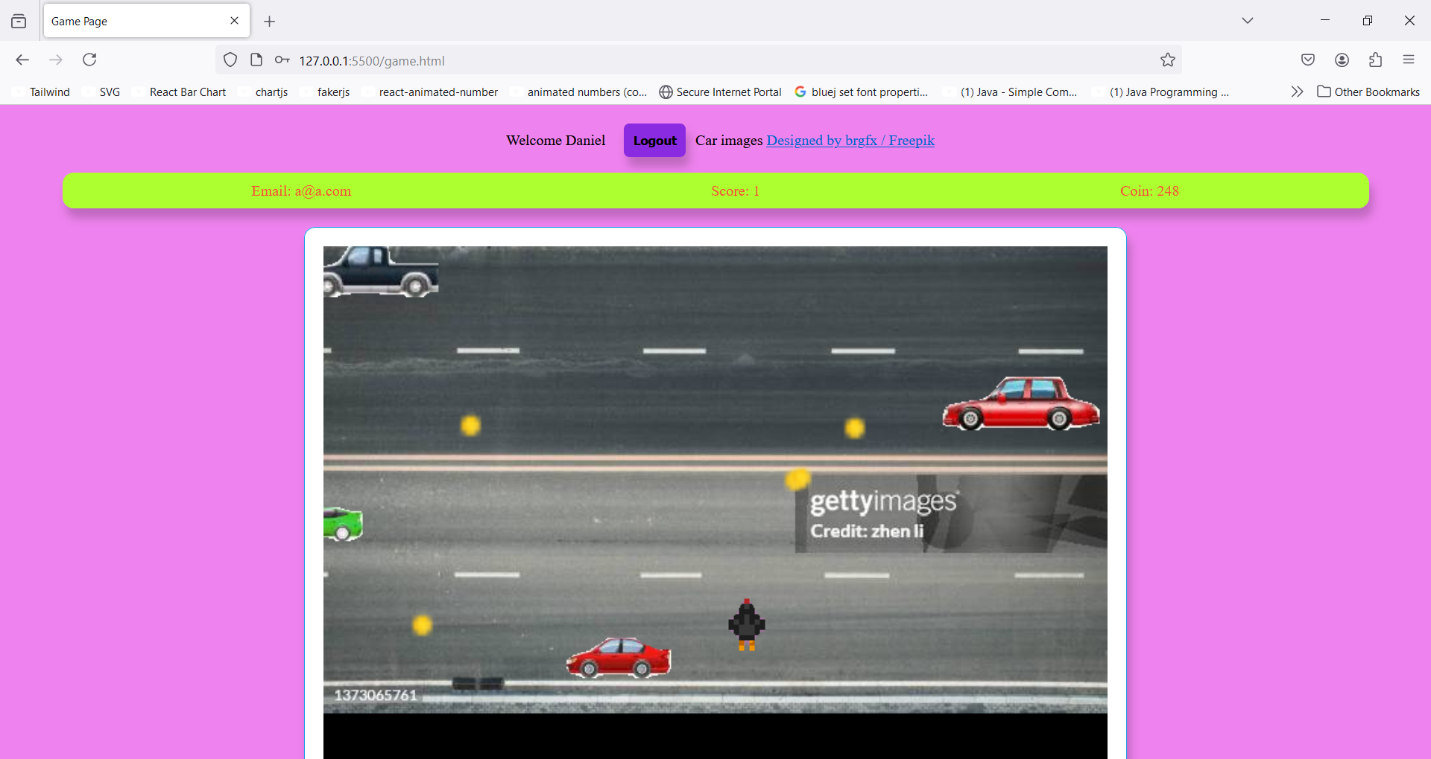



If a car hits the player their score updates back to the initial value which is 0 (however their highest score might alter, I explain it in users.html section):

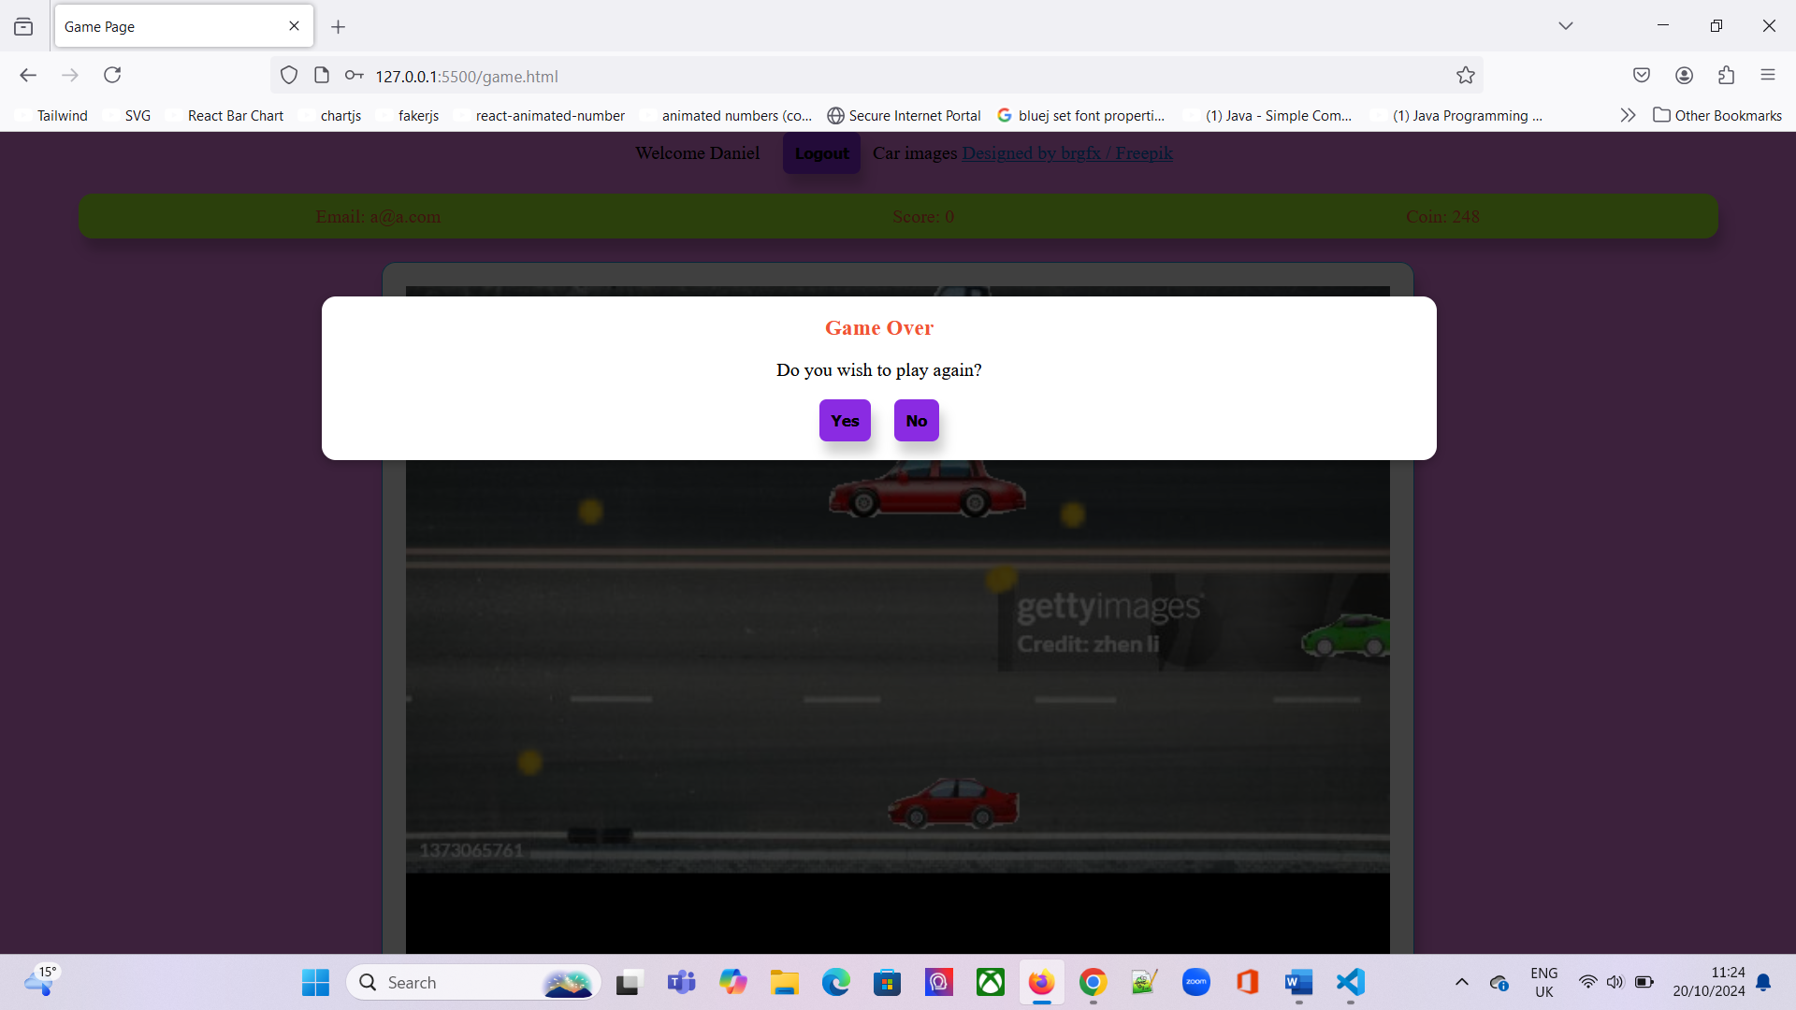

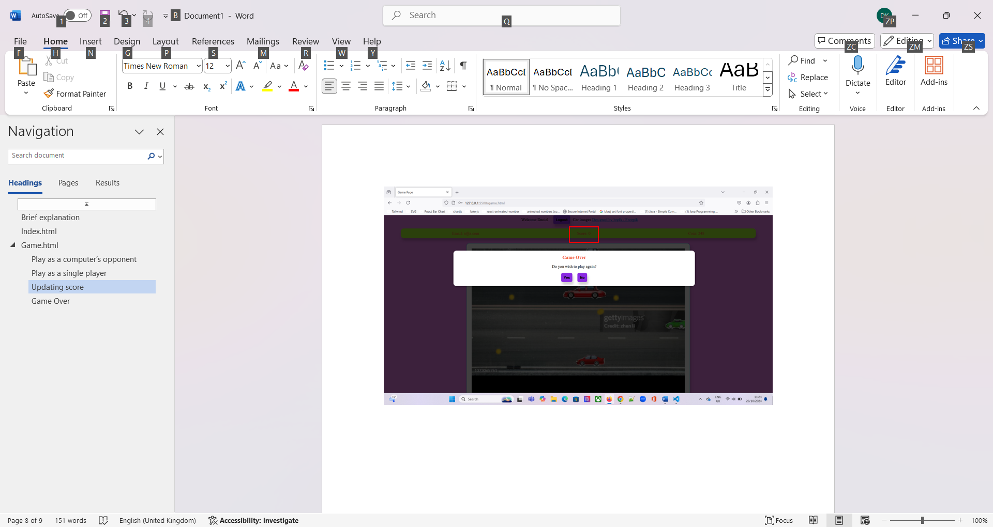

## Updating coin

Before the user pick up the coin, the amount of collected coins by far is 252:

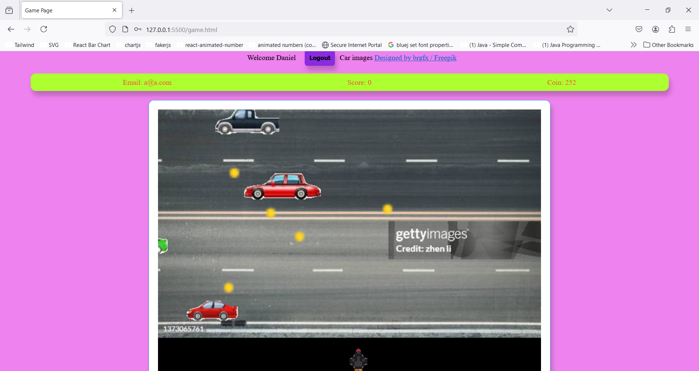

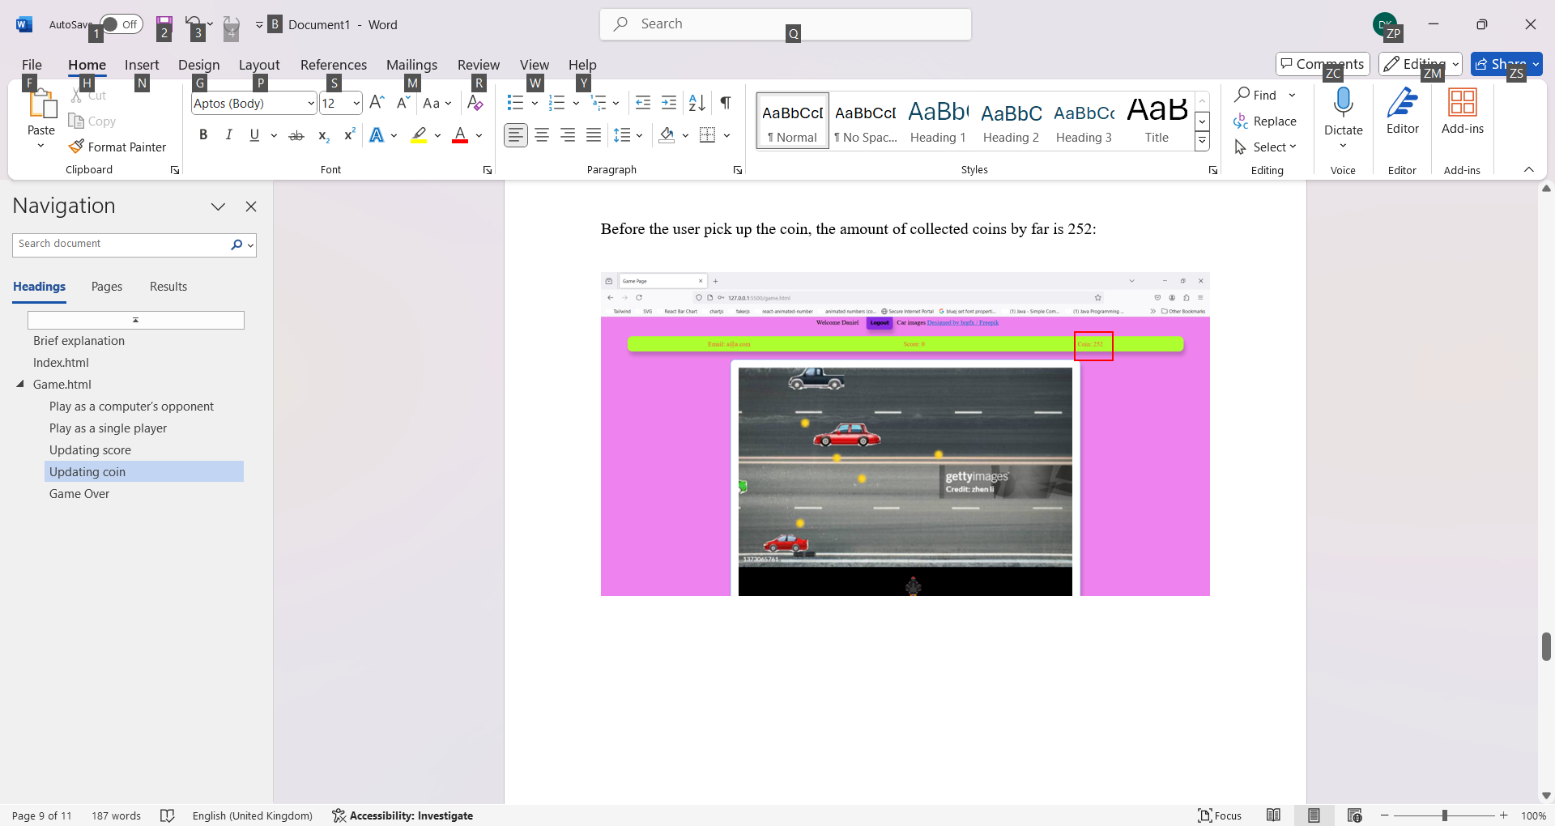

After the coin is acquired, the amount of gathered coins updates, now the absolute coins count to 253:

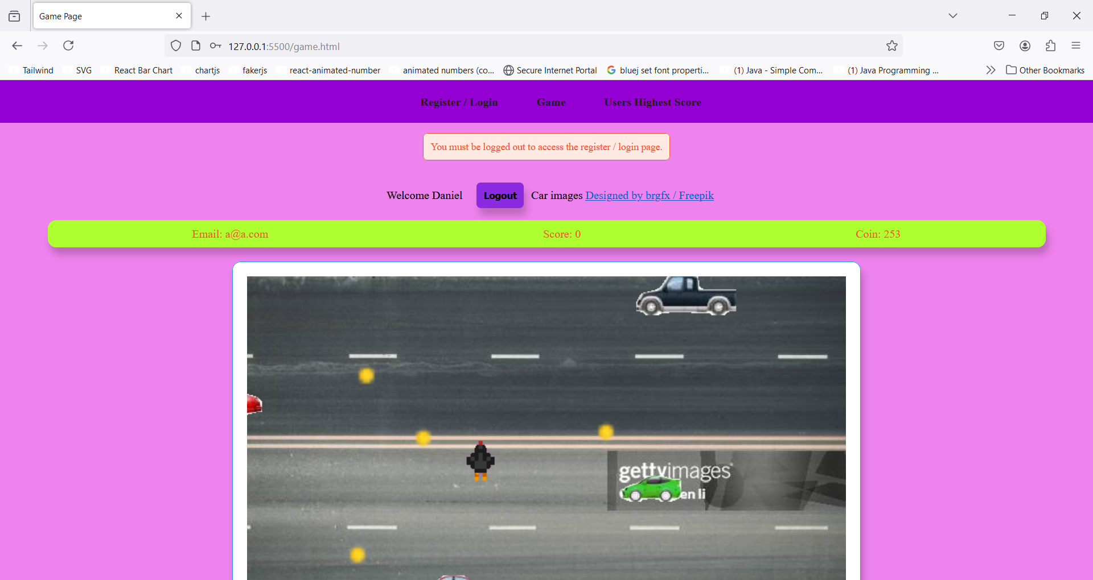



## Game Over

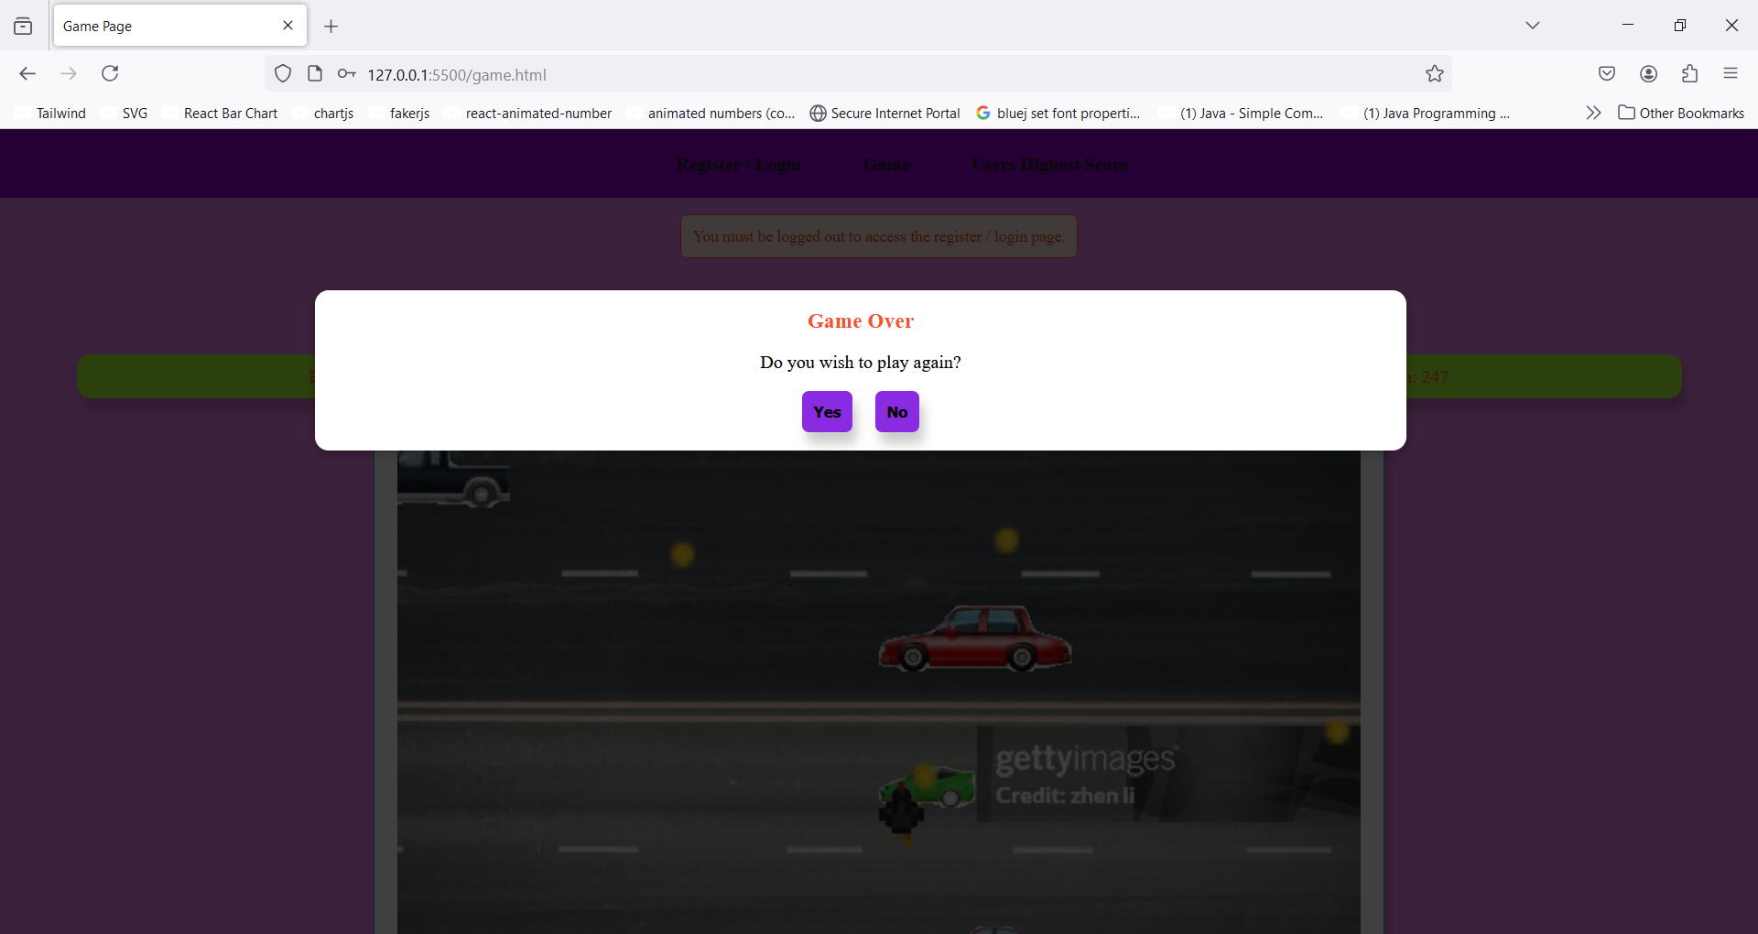

# Ranking table page

To induce changing to user’s highest achieved score and collected coins and display the updated score table I have logged in with another new user who’s their highest score and accumulated coins respectively are 1 and 2.

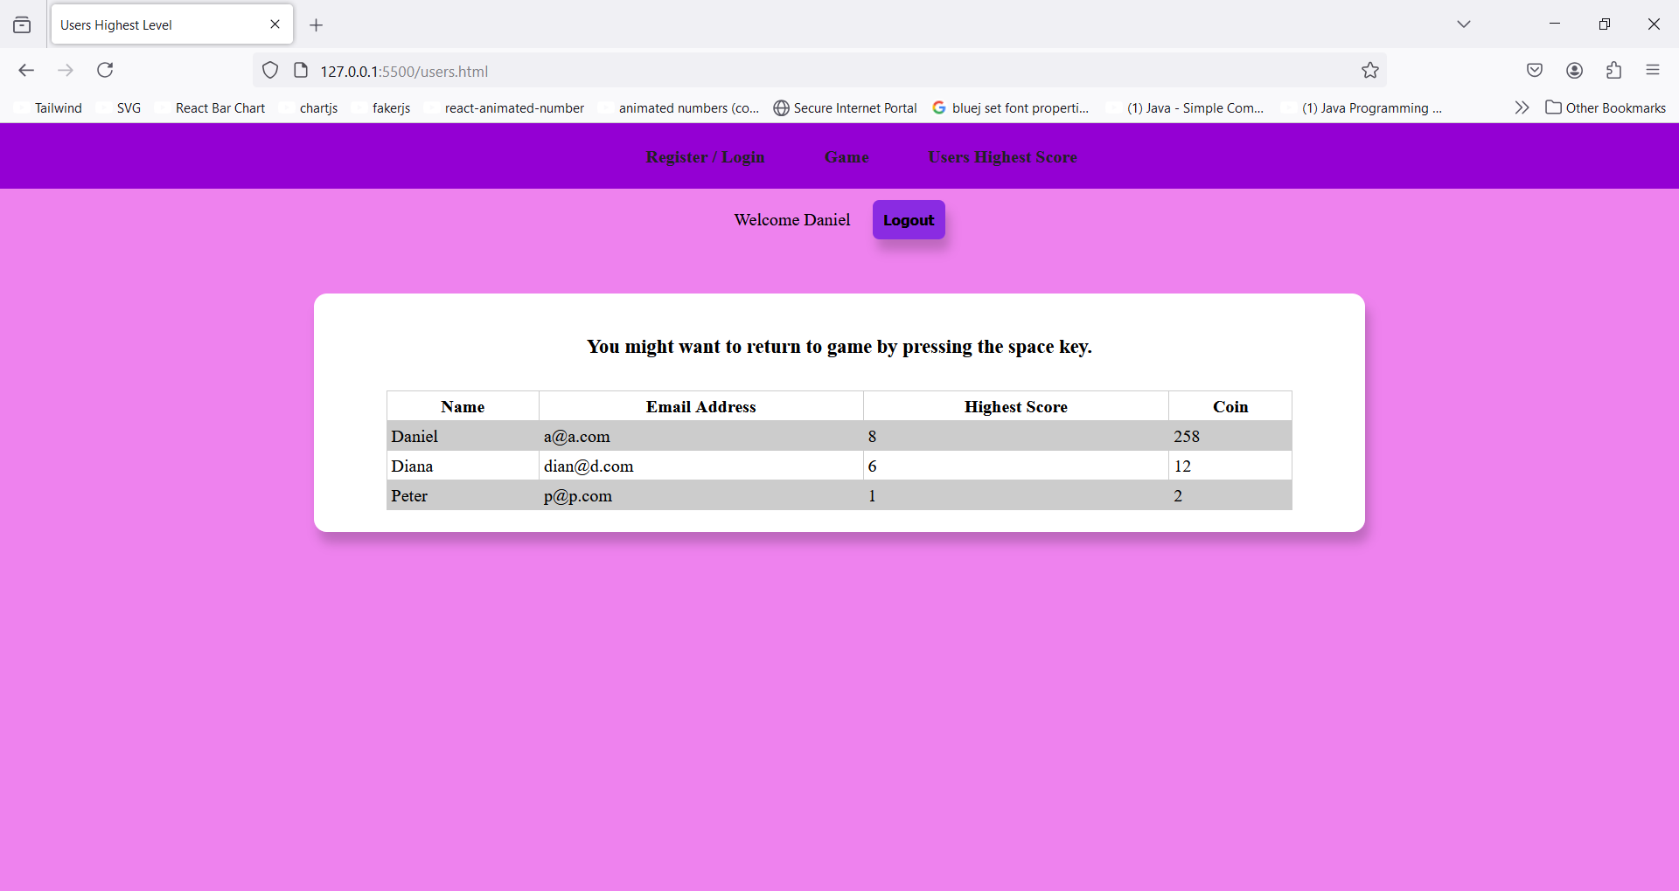

## Updating highest score

Highest score and score are utterly two different things, the user achieves score by passing a level, but highest score incremented only if the achieved score is greater than user’s previous score:

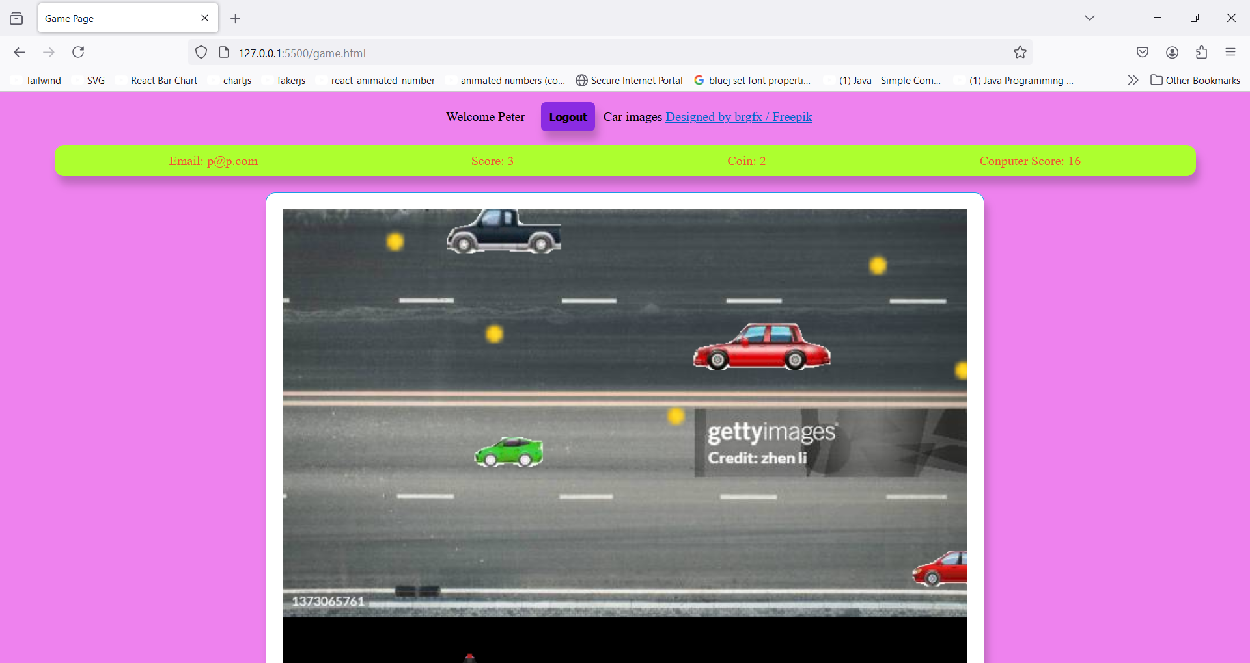



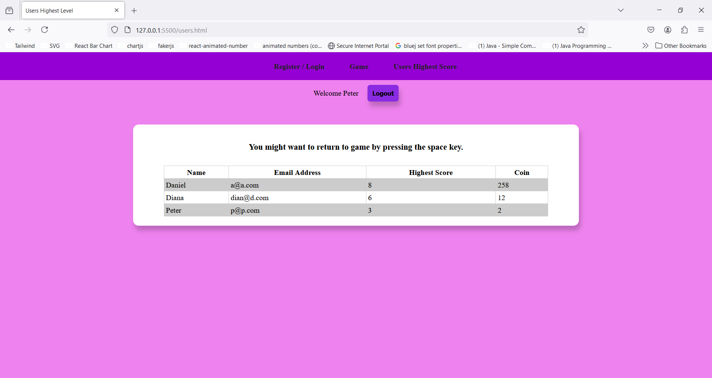

On the start of each game user’s score starts with value 0:

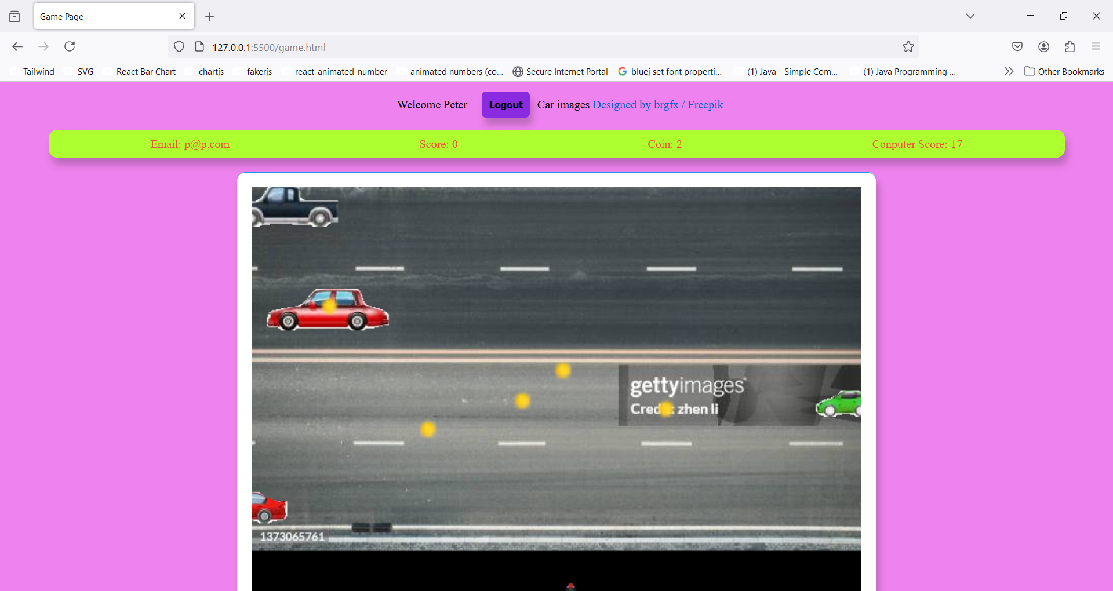



## Updating the stacked coins

The demonstration has been given in game.html header section but because it does not show the score table, I update the table exploiting the new user:

